Cover

Table of Contents
Introduction Page Numbers
Letter ?
Contact Information ?
Thrive Organizational Structure

Overview
Mountain Top Planning
Chapter Overviews
Phase 1: Discovery
Phase 2: Coaching

Chapter 1: Honoring Your Word
Executing the Insight
Meeting Kickoff with the Lodge

Chapter 2: You Are Not Your Past
Asking the Right Questions
Calling Out Red Flags
Diagnosing the Root Cause

Chapter 3: Taking a Stand
Crafting the Promise and Possibility Statement
Turning Story into Strategy
Executing the Steering Team Calls

Chapter 4: Something Bigger than Yourself
Establishing the Sub-Teams
Enabling the Lodge Chief

Chapter 5: Grip on the Ground
Catalyzing the Breakthrough

Chapter 6: Being Cause in the Matter
Shaping the Future

Chapter 7: Coaching Guidance
The 5 C’s of Coaching

The Foundation for High Performance

Dear Thrive Partner,

Methodology is deﬁned as “a system of methods used in a particular area of study or activity.” At Thrive, our methodology is deﬁned as “the ways in which we coach.” We believe in creating an inspiring, collaborative, and caring environment where individuals can perform at their natural best. The destination of a Thrive engagement is to achieve a breakthrough in performance: for both lodges and ourselves. The methodology laid out in this document is your roadmap to guide that journey.

Every lodge experiences unique challenges, but the way we support them in overcoming these challenges is consistent from engagement to engagement. The experience a Montana lodge has with Thrive should be congruent with the experience an Orlando lodge has with Thrive.

For example, crafting bold, inspiring, action-based “promise and possibility” is the foundation upon which a Thrive partnership primed for a breakthrough is built. Without a strong foundation, the partnership will be weak and the breakthrough unlikely. Every aspect of our engagements are focused on our ability to achieve breakthroughs together so that one day they can unlock bold possibilities for themselves. We don’t coach alone, and we certainly don’t inﬂuence decisions without the commitment of the lodge’s leadership. Our sincere hope is that by following the guidance laid out in this document, you’ll be able to crack the code to consistently create breakthroughs at the local level and, in turn, support the development of high performing lodges.

The following document outlines the roadmap for a successful coaching experience. Your team must be an ambassador of this (it’s the lifeblood of Thrive) . For us, this is what makes our team unique. It’s the “secret sauce” that everyone would like to be able to put on their sandwich, the thing that makes us the greatest transformational coaching program in OA history. We have a big journey ahead of us and countless lives to change. Let’s get to work.

Yours in WWW,

The Thrive Leadership Team

Thrive Organizational Structure

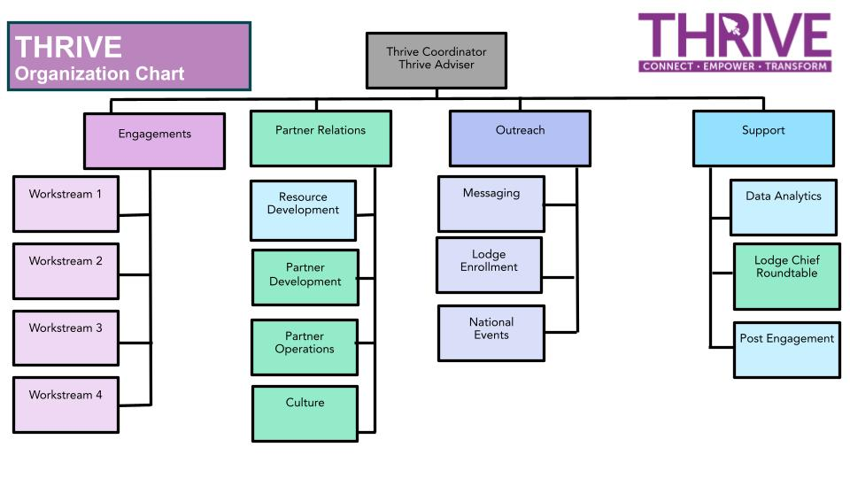

Overview
Mountain Top Planning - The Path to the Summit
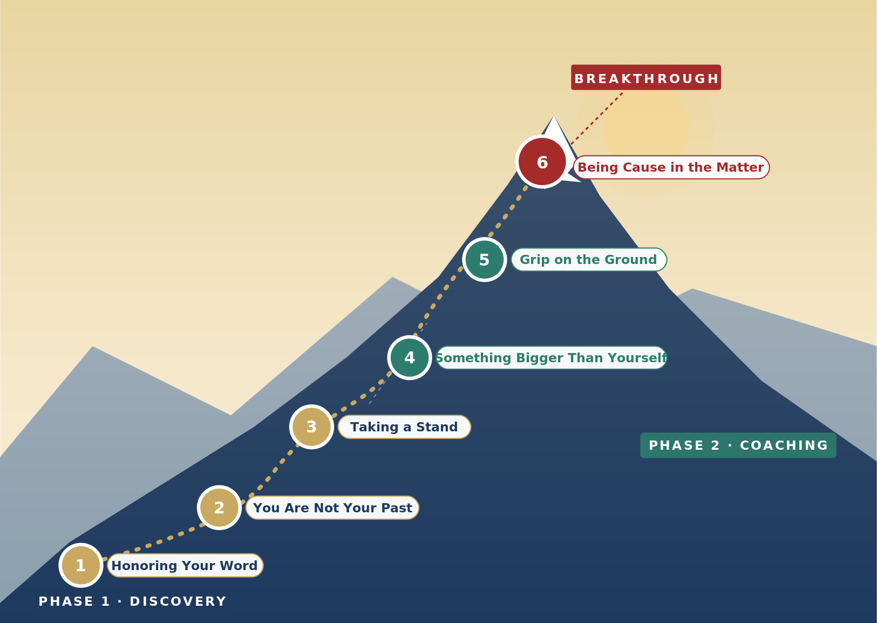
When devising a path up a mountain, it is easier to stand at the top of the mountain and look down, than to stand at the bottom and look up. From the top, you can see many different paths to the summit and many different starting places, while at the bottom there often appears to be only one way up.

Imagine when the team has delivered the promised result ( it will be more than an accomplishment, it will be a breakthrough). Breakthroughs don't come often, but when they do they are well planned and follow a clear roadmap.

While there are multiple details to achieving a breakthrough throughout this document, we follow six chapters to help us deliver the desired result. These six chapters help us not only navigate the direction of our coaching, but the magnitude of our impact.

Everything we teach you is important, but these six chapters are critical to the success of the engagement and partnership with the Lodge.

Each chapter is home to many steps throughout the partnership, such as identifying an opportunity for improvement in the discovery phase, and launching sub-teams in the coaching phase. Think of them as the guiding principles to realizing your success. You cannot execute the details without ﬁrst understanding the big picture.

A partnership is only as good as the integrity of those involved. Success cannot be achieved without maintaining it and holding one another accountable. In order to drive that sense of accountability, lodge leaders must understand that the past is behind them. One key component for the Lodge is to replicate it, but chart a path forward using lessons previously learned and using the current state as a starting point for transformation. . The current state of the chapter is not something that the current Lodge leadership (or previous leaders) are solely to blame. In fact, assigning blame is something that may prove detrimental to the engagement.. That mindset of transformation can only be achieved by taking a stand, and an individual must know what they stand for. That verbal commitment marks the turning point for an organization to create an inspiring reality.

The commitment of each individual is the ﬁrst step to creating a cutting-edge team. While Lodges rely on the talents of each individual, they also keep in mind that they are part of something bigger than themselves. Once a team is on the same page and the game plan is in full alignment, there is no mountain they can’t summit. It’s the result they have been preparing for with each interaction, conversation, and coaching session. Only when those teams can come together and get a grip on the ground have they truly taken control of their lives, and the opportunities that their actions can result in. They have a grip on the pulse of their impact — they’re being cause in the matter.

This is the breakthrough that we enable our lodges to achieve. Only by understanding what the path to the peak looks like can you successfully climb the mountain. Our summit is a breakthrough in performance, and these chapters are our roadmap to help them get there. It’s up to us.

Chapter Summaries
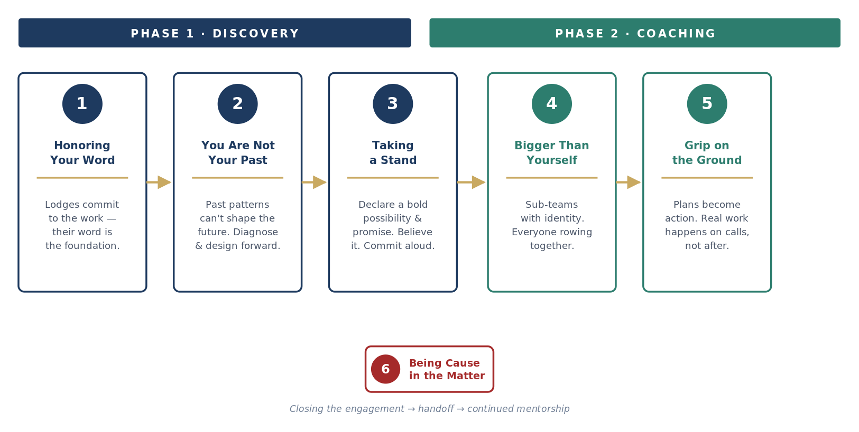

Honoring Your Word - Chapter 1
To be a person of integrity, you must commit to your word. Your “word” can consist of many things: doing what you say you’re going to do or when you say you’re going to do it. Doing things the way in which you know they’re meant to be done, what others might reasonably expect of you even if they don’t explicitly ask. In organizations where integrity means people merely keeping their word, leaders will only make safe, small promises. Organizations want leaders to make bold promises, knowing that sometimes they will fail to deliver. Creating a safe environment for failure by distinguishing between keeping your word and honoring your word is critical. You can’t always keep your word (meet a promise), but you can always honor your word (take responsibility for an unmet promise). When you don’t keep your word, honoring your word means cleaning up whatever mess you might have left with the situation. Declaring what your team can count on from you in the future shapes our ability to keep moving forward.
Key Takeaway: Your word is everything. Lodges need to commit to the opportunity of the partnership, and give their word that they are willing to put in the work to get to where they need to be to achieve high performance.
You Are Not Your Past - Chapter 2
Healthy organizations know that what worked for them in the past may not work in the future. Vicious circles — patterns of behavior that we keep repeating because they’ve worked in the past – can trap us. Designing a future that we aspire to, rather than dealing with the default future, can help your organization uncouple from its vicious circles. Transformational leaders stand out in the future. The future not as a concept, but as a reality that can be fulﬁlled. They can look back to the present and see what’s required for the future in terms of leadership, new sets of conversations, and accountability.
Key Takeaway: Lodges have dealt with overwhelming challenges for over a century. The Order has come far, but if we cannot adapt our behaviors to face current challenges, there may not be another century of the organization. It’s time to put that reality behind them. It takes everyone, from the lodge chief to the youngest member of the working team, understanding that they are not their past. They are the future.
Taking a Stand - Chapter 3
A declaration is a creative speech in which something is so because you said so and exists in the moment of speaking that possibility. Possibilities are declarations; possibilities are declared. A stand is a possibility to which you are committed. A stand is a picture of a future in words that inspire and move you. Your stand creates a future. Your stand sets up your senses to perceive and interpret opportunities for realizing your stand. Through a process of personal inquiry, listen for what inspires and moves you. Your stand must be authentic. Complete the statement: “I am the possibility of…“ What possibility would be so exciting and inspiring for you that just speaking it would pull you into action? A possibility is not designed to ﬁx things from the past. It is not personal to you. Possibilities include everyone. It is short and clear; it excites and inspires you.
Key Takeaway: Lodges have to take a stand in a new, bold future for themselves. They need to commit to, and believe in it. Simply writing a possibility and promise statement isn’t enough, they have to see themselves in it, they have to take a stand to achieve it.
Something Bigger Than Yourself - Chapter 4
To be committed to something bigger than yourself is to be open to possibility. This foundation attracts other people to you and your commitment. Being bigger than yourself also starts with taking responsibility. Responsibility starts with the willingness to deal with a situation from the point of view that you are the author, and the sole burden bearer of the results you produce on the world. When we foster a culture where we are striving to see others succeed before ourselves, the team achieves breakthroughs, and nothing can stop them.
Key Takeaway: A lodge leader cannot achieve a breakthrough on their own — it takes the whole team. You can’t win a rowing competition unless you can get your whole team rowing in unison. Sub-teams have to be established and committed to, with a distinct identity attached to them.
Grip on the Ground - Chapter 5
Organizations often get caught in a drift: the momentum of their status quo culture and operations. Committed conversations are key to interrupting drift. They’re a way to get people out of the path of your organization and onto the mountain. People can make four kinds of committed statements: A declaration about what is possible, a promise to move something forward, a request of somebody else, or a grounded assertion that something is so. Regardless of which you choose, you’re choosing a commitment to take action. There’s a time to stand at the base and make the game plan, but there’s also a time to start gaining traction, and start scaling the mountain.
Key Takeaway: Discovery and the ﬁrst month of transformational coaching are the foundation for planning, but now’s the time to turn their plans into action. Real work has to happen on calls. Plans have to be implemented. Accountability and follow through has to be present in every conversation.
Being Cause in the Matter - Chapter 6
To be cause in the matter of your life is to take a stand for yourself—and to commit to acting from that stand. This foundation gives you power and access to action for making a difference. Far too often organizations gain momentum that is eventually lost in the drift of commitment. They deliver a quality result and get their ﬁrst taste of success, then it all ends shortly after. Why? They lost their purpose — products don’t create high performance, people do. Those people have to continue to be committed to a cause, and have something to be inspired by. Understanding that once a checkpoint is reached a new one must be identiﬁed is critical to the longevity of the organization. That next step toward continued success can only be achieved by taking control of your work.
Key Takeaway: Lodges cannot use our partnership together as a crutch to take it easy when we’re gone. Our work with them should only be beginning. They have to realize that closing the engagement means building a new roadmap to achieving their goals, and commit to shaping that reality to put them on a path toward high performance — there’s always a new summit to reach.

Phase 1: Discovery
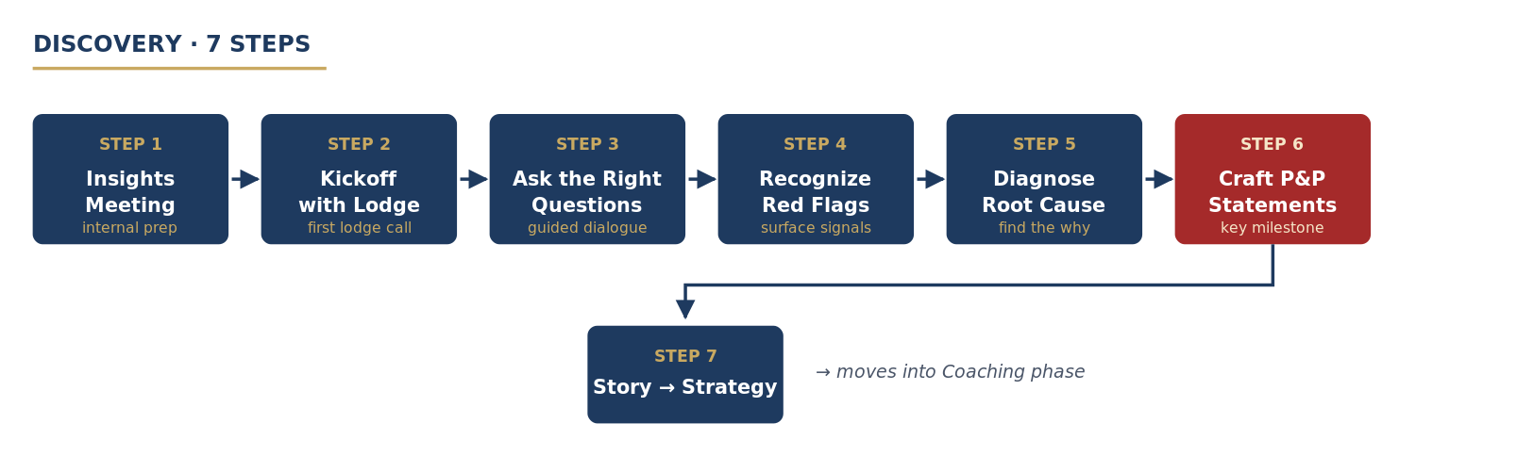
While there are more than 200 Order of the Arrow lodges, each with their own story, membership, and geography; their challenges are generally not very unique. Lodges across the country experience challenges in the same form, but the way in which they deliver their program varies. We all wear the same sash, but your experience as an Arrowman is completely dictated by the lodge you join. This is why we must strike a balance between a prescriptive and customized approach to providing coaching at the local level. Thrive achieves this balance throughout the discovery process through the following:

- Executing the insights meeting: Before ing with the lodge, it’s important to understand what you’re walking into. Using the help of data analysis and anecdotal insight, we schedule a meeting to enhance our knowledge of the lodge’s challenges and successes. While the data doesn’t tell us everything, it can often point us in the right direction. The anecdotal information from the local level also helps us support that data with real stories to strengthen our understanding.
- Kicking off with the lodge: The kickoff call is one of the most critical throughout the partnership: it sets the tone for every interaction. Utilizing the analysis gained in previous weeks, we want to walk into the kickoff meeting seeking to learn more, not diagnose causes, yet. While our partnership is about understanding their challenges and coaching them to overcome them, that cannot be accomplished without ﬁrst forging relationships built on trust.
- Asking the right questions: We know that lodges are most likely struggling in key performance areas – election rate, induction rate, and activation rate – and other critical areas, but why? Simply knowing that challenges exist isn’t enough, we must know where the root of the issue lies. The data tells us the result of their behaviours. Your job is to identify the behaviors that are producing the result and come up with a remedy. Said another way: you have a patient (the lodge) that has an ailment, and via the process of elimination, your role is to ask enough of the right questions so you can issue a diagnosis and then prescribe a remedy (promise and possibility) to get the lodge back to health. Using the list of red ﬂags, the engagement team should understand the lodge’s story through the framework of questions within this document. While every question isn’t critical, these are the right ones to ask. Getting answers to these questions will help your team identify where the major issues lie. Use the space underneath the question to write down and summarize their responses.
- Recognizing red ﬂags: As a partnership is beginning to kick off, there will be clear red ﬂags that should strike the engagement team as “something worth digging into.” For example, if a lodge has a 0% activation rate, they probably don’t actually activate 0 Arrowmen, they just don’t track it properly in OA LodgeMaster (OALM). Engagement teams should identify the red ﬂags they see as a result of the questions they asked.
- Diagnosing the root cause(s): After you’ve compiled the takeaways of your conversations and your team is aligned on some red ﬂags within the lodge, it’s time to diagnose the root cause. It is really important that when you are developing a promise and possibility (treatment plan) for the lodge (patient) that you are addressing the conditions that allowed for the cause to metastasize. For example: a lodge completes very few unit elections in one district in the council. It would be easy for your team to say that step one to recovery is simply for the lodge to complete more unit elections. When, in fact, step one to recovery is reestablishing relationships with the units in that part of the council. This will provide you a framework that you can use when crafting the Possibility and Promise Statements, and understand the direction your coaching needs to take in the future. You must analyze all underlying red ﬂags before you can diagnose the cause and prescribe a remedy. “We are moving slowly into an era where big data is the starting point, not the end.” – Pearl Zhu
- Crafting the Possibility and Promise statements: After you’ve diagnosed a cause, it’s time to work them into the Possibility and Promise Statements. The statements should be a reﬂection of the speciﬁc things they need to focus on, and the new bold future they want to create. Causes that your team identiﬁed should be represented within the statements. As a coach, it’s our responsibility to provide advice. Even when the leader doesn’t want to hear it or believe it.
- Turning the story into strategy: Once the Possibility and Promise Statements are enabled and your team has moved into the transformational coaching phase, you’re going to want to identify the strategies that best ﬁt your challenges. There’s even a chance none of the current strategies match your situation, and you’ll have an opportunity to add to our collection to further support teams in the future. The strategy provides a comprehensive framework, and key deliverables, that your team can utilize to help the lodge achieve a breakthrough in performance
Phase 2: Coaching
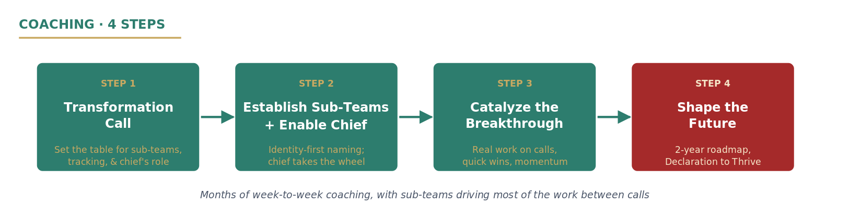
Understanding where a lodge is vs where they need to go is a critical component to breakthrough coaching. While the discovery process provided us with the story and the why, now is your team's chance to launch a robust implementation strategy. Thrive achieves this balance throughout the transformational coaching process through the following steps:

- Executing the Transformation Call: The first meeting that you will have is the transformation call. One of the main purposes is to explain the Lodge Chief’s hands-on role in the coaching phase, equipping them with the necessary resources to succeed. Be prepared to break down Promise goals with a clear definition of what completion looks like for each point. Introduce the Sub-Teams concept, working with your individual lodge to determine the best way to divide work among lodge leaders. Decide upon a way to track goals, giving the Lodge Chief a way to keep teams accountable and clearly communicate deadlines. Explain how the role of the Engagement Team changes from Discovery to Coaching.
Establishing the Sub-Teams: Once we’ve reached this stage of the partnership, our work generally operates in sub-teams. This allows us to spread our focus across several different problem points, and opens up opportunities for further involvement and discussion. Getting them off the ground is the hardest part, but once they’re up and running the teams are usually hitting on all cylinders. It’s critical that the individuals involved feel a sense of identity and belonging to their sub-team, and even more importantly, are inspired by the opportunities their work will create for their lodge.
- Enabling the Lodge Chief: Once the sub-teams are off and running, the lodge chief should be at a good point to drive things forward. It’s critical that they are taking the initiative on directing and managing change. They should be working with the engagement lead to check in with sub-teams, provide feedback, keep morale at a high, and keep the tactical implementation ﬂowing. You’ll want them to take the lead on opening and closing calls, laying the groundwork for the coaching call, and inspiring their team.
- Catalyzing the Breakthrough: Once the sub-teams are up and running, it’s time to create the results that will bolster their success. This doesn’t come from further planning or speaking in theoretical terms, but rather doing real work throughout the process. This is your team's chance to help the lodge conduct real work and implement real change on your calls. If done correctly, this process will catalyze a sense of momentum that will thrive long after the conclusion of our partnership.
- Shaping the Future: Once a breakthrough in performance has been achieved, and a lodge is well on their way to achieving their promise statement, it’s time to help them shape the future of their work. It’s our role as a transformational coach to help the lodge deliver success that translates into a future of growth and achievement. In doing so, we must help them develop a clear, compelling roadmap that both articulates their goals and turns those ambitions into a roadmap toward reality. Only then will our partnership be complete, our promise kept, and our word upheld.

Chapter 1: Honoring Your Word
Executing The Insights Meeting
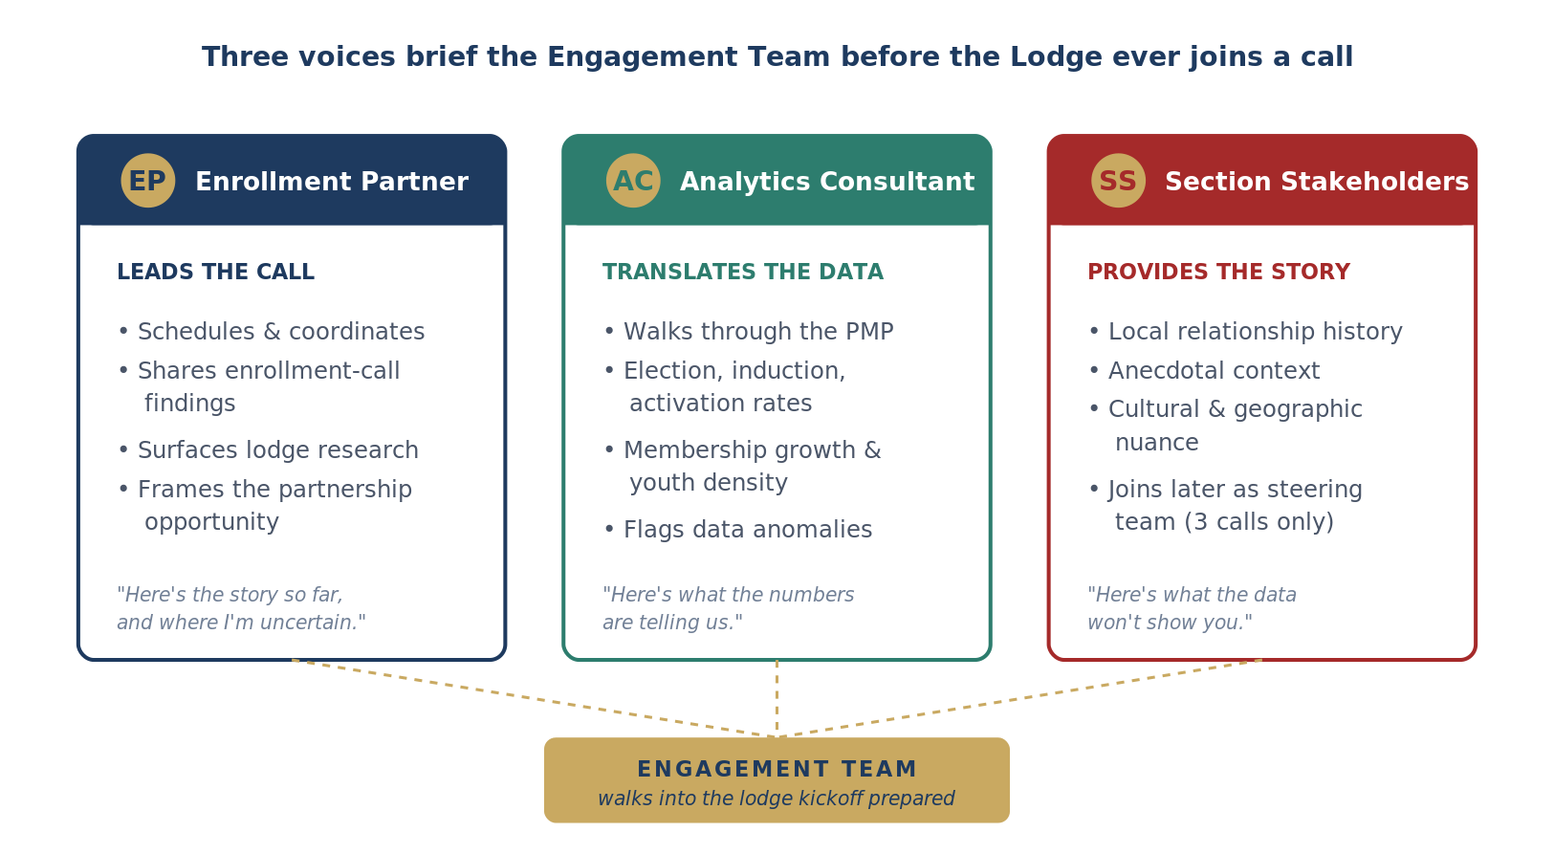
The outcomes of the insight meeting is to gain a deeper perspective of a lodge before walking into a kickoff meeting with them. We do this by pairing the engagement team with three stakeholder groups:
- Enrollment partners
- Analytics consultants
- Section stakeholders

While these three stakeholder groups are present and take an active role in the discussion, the enrollment partner leads the meeting.

The assigned enrollment partner will coordinate scheduling time with the engagement team and analytics consultant. The enrollment partner will kick off the call, providing their feedback on their experience with the lodge thus far. This will include items learned through research and their conversations on the enrollment call. The analytics consultant is there to translate the results of the lodge’s Performance Measurement Program (PMP). They will walk through the document and explain what the lodge’s largest challenges are, or at least what the data tells them. This will involve the areas of unit election, induction, and activation rate, membership growth and youth density, and overall performance. Their main role is to ensure your team has a good grasp on the lodge’s data before moving into the kickoff meeting. Make sure to ask any questions you’re unsure about regarding the data on this call.

The section stakeholders are there to help us learn more about the lodge’s story. Naturally, there are two ways these stakeholder groups will react to the partnership with Thrive:
- They will be welcoming and encouraging, and probably have a well established relationship with the lodge, or
- They will be apprehensive and non-welcoming, and probably be cautious to receive help from an outside group. You need to be prepared for either outcome.

First of all, the section hopefully has a pre-existing relationship with the target lodge, but you do not work for them. They are there to help you and your team be successful, but they are not Thrive Partners. You should be welcoming and receptive to their feedback regardless of whether their immediate reaction is positive or negative. Focus on building trust and strengthening those relationships and let the chips fall where they may.

It’s also important to inform the section stakeholders that their role in the Thrive partnership will exist as part of the engagement’s steering team. They will be updated during 3 calls throughout the engagement; one following discovery, one mid-transformational coaching, and one to conclude the engagement. We value their insight, but they are not meant to be involved in day-to-day operations. Be transparent with them about the partnership and its intended outcomes, and tell them you’re thankful to engage with a lodge in their section.
Kicking off with the Lodge
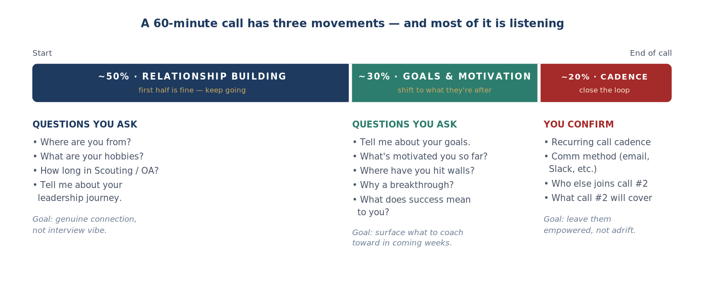
The kickoff meeting is the opportunity to establish real, genuine trust right off the bat. If the lodge leaders leave the kickoff call with a negative or hesitant mindset, your ability to inspire and inﬂuence change will be extremely difﬁcult. The call should focus on developing trust through a deep understanding of the lodge’s circumstances. This means that the lodge should be speaking for most of the call, however, all the TC partners should take time to engage in questions & relate to the responses. First, it’s important to build a genuine ion. The partners need to prove that they care beyond simply seeing the lodge be successful. Start off with some personalized questions to the lodge chief & adviser. Try to phrase them in such a way where it feels natural, and not so much like you’re interviewing them. Some options include: So tell me, where exactly are you from in (insert state)?
- Maybe follow up with a question about the area.
- What are some of your hobbies?
- Where do you go / study in school / do for work?
- How long have you been in Scouting & the OA?
- Tell me about your leadership journey, how did you get to this point?

All of these questions provide an opportunity for lodge leaders to tell the partners quite a bit about their personal, Scouting, and leadership experiences. It supports our efforts in building a genuine ion with them, and will lead to unlocking deeper and more meaningful trust as the engagement progresses. This may take up the ﬁrst half of the call, and that’s perfectly okay! Next you want to shift into building on the pieces of the puzzle that may be missing or needed.
- So, tell me about some of your goals this year.
- What about your term thus far has really motivated you to stay positive?
- Have you experienced any challenges in achieving your goals?
- Why do you want to achieve a breakthrough in your lodge?
- What’s your deﬁnition of success?
- What advantages do you believe could be represented if a breakthrough is achieved?

Finally, you want to end with ensuring that the lodge leaders are empowered and motivated for more coaching from the TC partners. Here’s some key points you want to be sure to not leave out.
- Develop a cadence for recurring phone calls.
- Set a method for communicating - emails, slack, etc.
- Explain the importance of the working team: who you want, what positions, who they want, and enable them to add them to the method of communication, and set the expectation that all stakeholders should join the partners for the second call.
- Provide some insight as to what the second call will entail.

Once you’ve done these things - you have ensured a successful kickoff call, and can continue forward with questions from the list below! Following each remaining discovery call, the partners should ask the working team to brainstorm one question before the next call, and open by answering each one:
- During an election, what is a rough agenda of the presentation the Arrowmen gives prior to the election? How do they promote the OA and your lodge?
- How does your lodge stay in contact with elected candidates to promote the induction opportunities?
- Can you describe what the outreach process for newly inducted Arrowmen looks like? Do you reach out to invite them to any sort of activation event, or do they ﬁnd out elsewhere?

Chapter 2: You Are Not Your Past
Asking the Right Questions
Discovery Questions Guide

Recognizing Red Flags
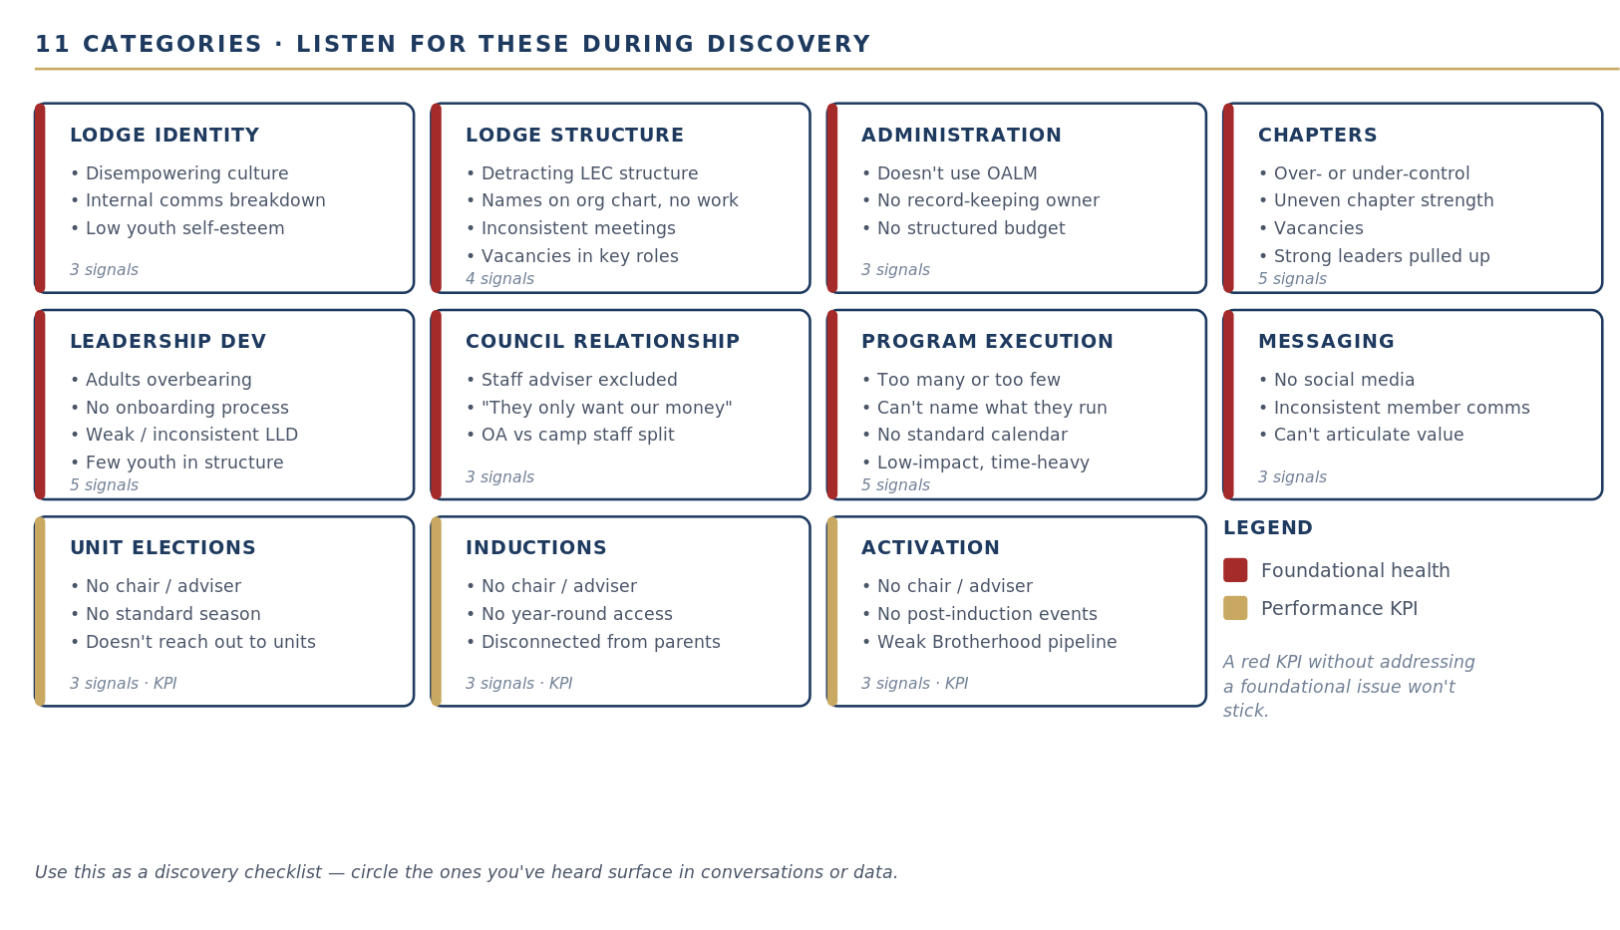
Lodge Identity
- Lodge has a disempowering culture
- There is a clear breakdown of internal communication
- Youth leaders display low self-esteem

Lodge Structure
- Lodge executive committee structure is detracting, not supporting, their ability to deliver a stellar program
- There are a lot of names on an org chart that do not actually do anything
- Lodge executive committee does not meet often or on a consistent basis
- Lodge has vacancies in youth & adult leadership positions, such as ofﬁcers and key advisers

Lodge Administration
- Lodge says they don’t use OA LodgeMaster for anything
- Lodge doesn't have anyone accountable for record keeping
- Lodge doesn’t have a well structured budget

Chapters
- Lodge is overbearing to chapters in the unit election process; does not provide enough ownership of the process to chapters
- Lodge does not provide enough oversight to the chapters in the unit election process; gives too much leeway to chapters
- Some chapters are signiﬁcantly stronger than others
- Chapters have vacancies in youth & adult leadership positions
- Whenever there is a strong leader in a chapter, that leader is pulled from their chapter role and promoted to the lodge level

Leadership Development
- Adults are overbearing, controlling, or unempowering
- Lodge doesn’t have a standard process for on-boarding new ofﬁcers, committee chairs, advisers
- Lodge doesn’t hold an LLD or doesn’t have a consistent one
- Leadership training program is weak
- Lack of youth involved in the leadership structure

Council Relationship
- Lodge asks for staff adviser to not be included on calls, or staff adviser seems unengaged
- Lodge says the council only cares about them for service or their bank account (i.e. Friends of Scouting (FOS) donations)
- Lodge says that “the OA and summer camp staff” are two different audiences

Program Execution
- Lodge runs an overwhelming amount of programs each year
- Lodge runs surprisingly few programs each year
- Lodge can’t name off many programs they run each year
- Lodge doesn’t have a standard operating calendar
- Lodge is overly invested in low-impact, high-time commitment programs

Messaging
- Lodge doesn’t use social media
- Lodge doesn’t consistently communicate with their members
- Lodge cannot speak to the value they provide to Scouting

Unit Elections
- Lodge doesn’t have a unit elections chairman & adviser
- Lodge doesn’t have a standard unit elections season
- Lodge doesn't actively reach out to units / unit leaders

Inductions
- Lodge doesn’t have an inductions chairman/adviser
- Lodge doesn’t offer easy access induction opportunities year-round
- Lodge doesn’t with parents in any way, shape, or form

Activation
- Lodge doesn’t have an activation chairman/ adviser
- Lodge doesn’t offer easy access activation opportunities post induction
- Lodge doesn’t offer ample brotherhood conversion opportunities on a 6 month post induction timeline

Diagnosing the Root Cause(s)
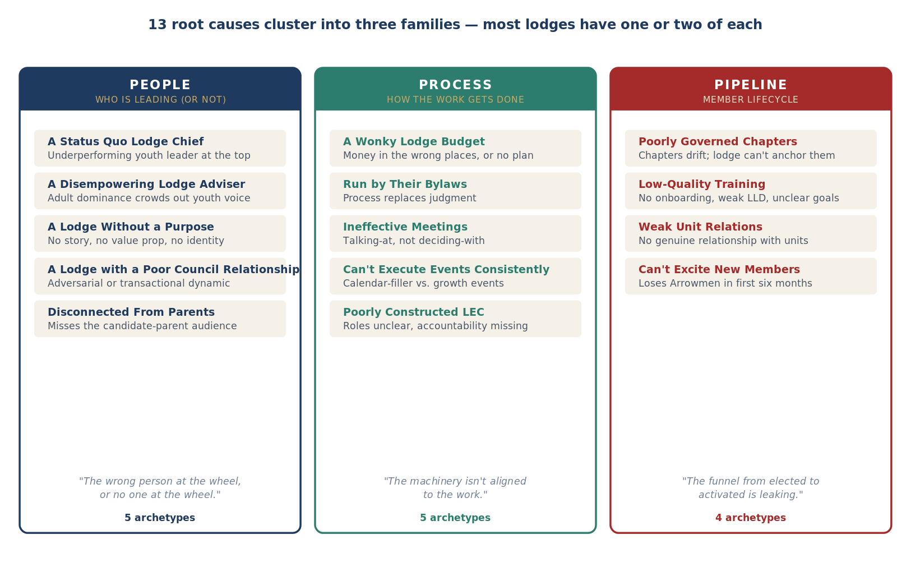
A Status Quo Lodge Chief
Synopsis: Coaching a lodge chief directly is a critical component of the Thrive program. Being a lodge chief is, without a doubt, the most critical role in the Order of the Arrow. The decisions made from week to week by a youth (often in high school, mind you), drastically dictate an Arrowmans experience at the local level. Lodge advisers keep the train running, yes, but enthusiasm from the members live and die at the impact of the lodge chief. It’s not enough to keep the train on the tracks, we need high performing lodges. If a lodge chief is underperforming, or operating in a rut, there will be clear signals that reinforce your thinking.
Signs:
- Lack of understanding of the Order of the Arrow
- Obvious disempowerment
- Poor communication skills, both verbal and written
- Lack of motivation
- Lack of a real adviser

A Wonky Lodge Budget
Synopsis: Believe it or not, lodge ﬁnances can greatly impact their ability to consistently deliver high quality programming for their members. We see this problem far too often, but generally feel the effects in the ﬁrst six months of the membership journey more so. Many lodges not only have a poorly structured budget—but they’re spending their money in the wrong places. Having a high quality lodge budget is an easy win that can boost credibility in a matter of weeks.
Signs:
- They don’t even have a lodge budget
- Youth leaders have never seen the budget
- Nobody can tell you how much money the lodge operates on
- You’re told that ﬁnances “aren’t a big deal to them”
- They are more concerned about patches than anything else
- They don’t allocate resources to support critical areas (elections, inductions, and especially activation)
- They unintentionally (or not) create ﬁnancial barriers for their members, especially recently inducted ones

A Disempowering Lodge Adviser
Synopsis: Lodge advisers play a critical role in the Order of the Arrow. Considering their role usually doesn’t turn over every year, they are the anchor of their lodge — they keep them grounded. Unfortunately, some lodge advisers don’t use their position to directly impact youth, directly contradicting a major reason that this program exists.
Understanding where a lodge adviser’s inﬂuence is positively and negatively affecting the culture of a lodge is essential to driving a path forward toward alignment.
Signs:
- The youth leaders don’t speak up on calls (leverage mural if so)
- The youth leaders ask for approval on every decision they make
- A lodge adviser always answers before the youth leaders
- A lodge adviser tells you this isn’t necessary

A Lodge Without a Purpose
Synopsis: Lodges can get lost in the cycle of understanding why they exist, who they serve, and what they stand for. A lodge who doesn’t understand their value proposition will generally see that carry over into key areas of their work. Many lodges don’t know who they are simply because they don’t know who they can be. Lodges understanding who they are, and positioning that story behind everything they do is essential to the work of the Order at the local level.
Signs:
- Lodge leaders struggle to articulate what their lodge does
- Lodge lacks a real brand and identity
- Lodge cannot articulate how they beneﬁt the organization or serve their council

A Lodge Run by Their Bylaws
Synopsis: Bylaws may seem like a simple document, but they unite Order of the Arrow lodges around common structures. Each lodge has a unique set of bylaws and operations — a nationally recognized approach doesn’t exist. Bylaws are great to provide structure, but far too often lodges allow them to dictate their work and trap their decisions. Just like the organization itself, lodges must innovate and challenge the status quo — their bylaws shouldn’t be allowed to run them.
Signs:
- Lodge leaders say they need to “check the rules” before making a decision
- Lodge leaders lack the inspiration to innovate because of “the way it’s always been”
- Adult leaders continually lean into the bylaws as if it’s a crutch

A Lodge Who Runs Ineffective Meetings
Synopsis: Meetings play a huge role in an Order of the Arrow lodge. From lodge executive committee meetings to event planning sessions, these critical conversations often drive decisions executed at the local level. Meetings can also be an inhibitor if they are run poorly. Volunteers don’t want to be “talked at”, they want to be inspired. As lodge leadership, it’s their job to lead the conversations that will inspire a future lodge chief to become involved today.
Signs:
- Lodge leaders have a hard time speaking up on the calls
- Lodge leaders cannot consistently drive an agenda for calls
- Lodge leaders cannot articulate why they have meetings for certain aspects of their program

A Lodge Who Cannot Consistently Execute Events
Synopsis: It’s often said that Arrowmen would make great event planners, because our success often lives and dies on the quality of our programming. Lodges often get caught up in the weeds of event planning, and lose consistency in each individual event. While many events are necessary, some may exist solely as a distraction from the ones that truly create growth opportunities. Regardless — lodges need to consistently deliver high quality programming for their members each year.
Signs:
- Lodge leaders identify too many events to even wrap your head around
- Lodge leaders don’t have a functioning (it actually works) accountability structure in place for their events
- Lodge leaders seem to be holding events “just to ﬁll the calendar”

A Lodge with Poorly Governed Chapters
Synopsis: While not every lodge has them, lodges that have chapters rely heavily on their ability to deliver in key areas. For a large lodge, chapters are the lifeblood of an Arrowman’s experience — from their involvement to their identity, it’s where they call home. Far too often lodges don’t recognize this and lack the accountability structures necessary to help their chapters thrive.
Signs:
- Lodge has far too many chapters for their size / geography
- Lodge leaders cannot tell you the names of the chapters or who their represented leaders are
- Lodge solely relies on the chapters to deliver election, induction, and activation opportunities

A Lodge Who Had a Poor Relationship with Their Council
Synopsis: Lodges are the epitome of what success should look like within a council. Councils can often be the lodge’s largest champion, but far too often they seem to be their largest critic. For the longevity of a lodge’s success, it’s critical that they have a solid working relationship with their council. From funding to logistics, they rely on them for far too much to have a poor relationship with their council.
Signs:
- Lodge leaders don’t speak highly of their staff adviser or include them
- Lodge seems like a piggy bank for the council’s operations
- Lodge refuses to engage with summer camp opportunities or programming

A Lodge with a Poorly Constructed Executive Committee
Synopsis: Lodges live and die on their commitment to ensure quality leadership year after year. In an organization where new youth leaders are elected every year, this can become a large challenge over time. A LEC should operate like a well oiled machine, and when it doesn’t, everything can fall apart quickly, from operations to strategy. The LEC should drive the vision of the youth leaders, and shape the framework for an Arrowman’s experience.
Signs:
- Lodge has unnecessary amount of positions available
- Lodge leaders don’t know their role or what they’re accountable for
- Lodge leaders can’t articulate how each position beneﬁts the work of the lodge

A Lodge Who Delivers Low-Quality Training
Synopsis: Training is a continuous function that’s represented in every Order of the Arrow lodge. From onboarding programs to lodge-wide development opportunities, it’s a large part of who we are. Oftentimes, lodges lack the ability to consistently deliver high-quality training that inspires the next generation of Arrowmen to step up and dream big. Their impact is critical to driving retention.
Signs:
- Lodge leaders claim they weren’t onboarded for their role
- Lodge leaders cannot consistently articulate what the goal of their LLD is
- Lodge leaders claim that getting youth engaged is a large problem within their organization

A Lodge with Weak Unit Relations
Synopsis: Units are the largest drivers of the OA program — they are the backbone of our membership. Conducting unit elections is the single most important factor to driving retention — you cannot induct or activate someone if you don’t elect them ﬁrst. Unfortunately, too many lodges lack the ability to foster genuine relationships with the units in their council, and as a result, suffer long-term membership loss.
Signs:
- Lodge leaders don’t create an atmosphere where a unit elections chairman can be successful
- Lodge conducts unit elections “whenever they want to”
- Lodge expects unit leaders to reach out to them or they don’t schedule an election

A Lodge that Doesn’t Connect with Parents
Synopsis: We know that to consistently ensure candidates are attending induction opportunities, parents of those elected candidates must be on board for the organization to impact their child. Too often lodges don’t recognize this, and as such, lose one of their largest target audiences in the process. For a 13 year old Scout, their parents are encouraging their involvement and helping keep them motivated, and they won’t do it for an organization they’ve never been given a reason to believe in.
Signs:
- Lodge aren’t sharing a story founded on meaningful ions—instead of one that resonates as a compelling sell to parents of elected candidates and inducted members
- Lodge isn’t providing parents multiple opportunities to encourage their child complete the Ordeal
- Lodge doesn’t deliver a compelling marketing strategy, or separate opportunities to with parents of elected candidates

A Lodge that Can’t Create Excitement with Their New Members
Synopsis: Scouts are elected, they complete their ordeal, and we think we have them right? That’s what far too many lodges across the organization believe, and as a result, they’re paying the price. An Arrowman’s experience is most likely to be impacted within the ﬁrst six months following their induction. It’s critical that lodges go above and beyond to activate newly inducted members, allowing them to earn brotherhood.
Signs:
- Lodge doesn’t have the accountability structures in place to build meaningful ions
- Lodge doesn’t believe in events that exist “solely to excite new Arrowmen”
- Lodge calendar isn’t optimal for an Arrowman to obtain Brotherhood six months following their induction

Chapter 3: Taking a Stand
Crafting the Possibility & Promise Statements
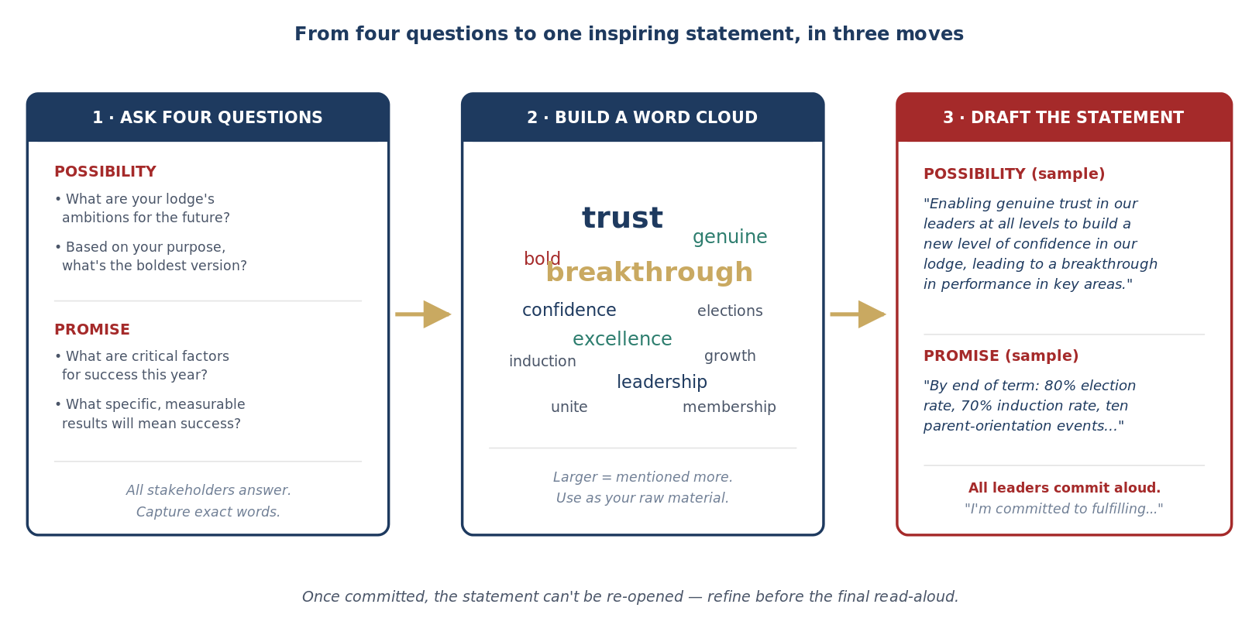
To develop inspiring Possibility and Promise Statements, you’ll need the lodge stakeholders to provide answers to four questions:

- Possibility: We want to deﬁne a bold and inspiring future for our team with one foot in reality and the other in possibility. The possibility statement should be something inspiring and challenging; something unlikely, yet doable. To help create this statement, here are some questions we'd like you to answer:
  - What are your lodge’s ambitions and/or aspirations for the future?
  - Based on your purpose, what do you see as the biggest, boldest ambition for your lodge?
- Promise: For this, we want to deﬁne speciﬁc and measurable results that we will achieve by X DATE (usually end of term unless that’s too short of a timeline). Here are some questions for you to think about and answer:
  - What are some critical factors for your lodge’s success in the future?
  - What speciﬁc and measurable results do you see as necessary for you to say that your lodge’s work this year was a success?

Once you have answers to these questions, you’ll need to pull the most common themes from the conversations to forge each piece of the statement. You can see the threads where Thrive’s original statements were built here. To draft an inspiring promise and a bold possibility, you’ll need to take the answers to the four questions you previously asked and plug them into full statements through the following mechanisms:

- Build a word cloud out of the most used words. This will help you (and the lodge) visualize the things that are most important to them. Remember, you may have your own ideas, but this has to be their statement. We need to take their ideas and translate them into something valuable that encourages action.
- Take the word cloud and plug them into ambitious statements. For example, in the wordcloud here, we see words like “trust”, “genuine”, “conﬁdence”, and “breakthrough”. A bold subset of a possibility statement could look like:
  - “Enabling genuine trust in our leaders at all levels to build a new level of conﬁdence in our lodge, leading to a breakthrough in performance in key areas ”
  - “As one of the strongest lodges in the Order of the Arrow, X lodge will deliver on our promise of excellence by…”

Once you’ve pieced together word clouds for the components of each statement, make sure they are grammatically correct and ﬂow well. It’s a good practice to look at previously assembled possibilities and promise statements to ensure the one you and your team have forged is up to par. Obviously there are things that are important to both us and the lodge, and that’s where the partnership aspect comes into play. The statements should articulate their goals and vision, but should also lead them on a path toward high performance in the key performance indicators of unit election, induction, and activation rate, as well as overall youth membership growth. Once the statement is ﬁnally assembled, make sure to communicate with your workstream leaders to receive insight and feedback. A lodge can never backtrack and change this once they’ve committed to fulﬁlling it, but it can be ﬁxed before the ﬁnal presentation to the lodge. On the call where all stakeholders ﬁnally agree, you’ll want to ask each lodge leader to unmute themselves and say “I’m committed to fulﬁlling our possibility and promise.” Leaders are statistically far more likely to achieve goals that they verbally commit to.
Turning Story Into Strategy
Thrive supports lodges all across the organization, but the strategies that we use to coach are consistent among teams. We don’t expect our teams to reinvent the wheel every time they have to work through problems in an engagement. Once the team has learned the story, it’s time to implement the strategy.

Strategies for coaching are highly dependent on the situation the lodge is experiencing. For example, a goal of ours is to help the lodge build a structured unit elections team that travels unit-to-unit, we will need to equip them with a development program to do so. If a lodge wants to run a parent orientation prior to an induction opportunity, we need to provide the template that they can put into action.

Instead of recreating these deliverables every time we coach a new lodge, Thrive utilizes an in-house Strategy Playbook for our teams to use (internal use only). The guide has resources and deliverables that span across many of the pain points that your team has already identiﬁed. Using this playbook will help your team implement quick-win strategies to boost the success of your lodge, however, it’s important that the lodge doesn’t know this playbook exists. They should feel as though these strategies were hand picked for them.

The strategy may not be exactly what they need, and it’s okay to customize it to their needs. You should help them and their branding to the deliverables, and build their identity into the resource. It’s theirs; we want them to own it. You’re free to use any and all resources that currently exist within the playbook. Additionally, the goal of the quick wins playbook is not to remain static. Every engagement is going to experience a problem that we didn’t plan for, and that’s why we recruit innovative talent to join our team. If you have an idea for a resource that needs to be created, let us know through Slack and our Resource Development team will step up to the challenge!

These strategies should provide the framework for your coaching. Think of them as the path forward to solving the root causes your team identiﬁed — they’re a game-changer for your coaching. These strategies will be your path forward during the transformational coaching phase, but don’t let it stop your team from being creative during discussions.
Executing the Steering Team Calls
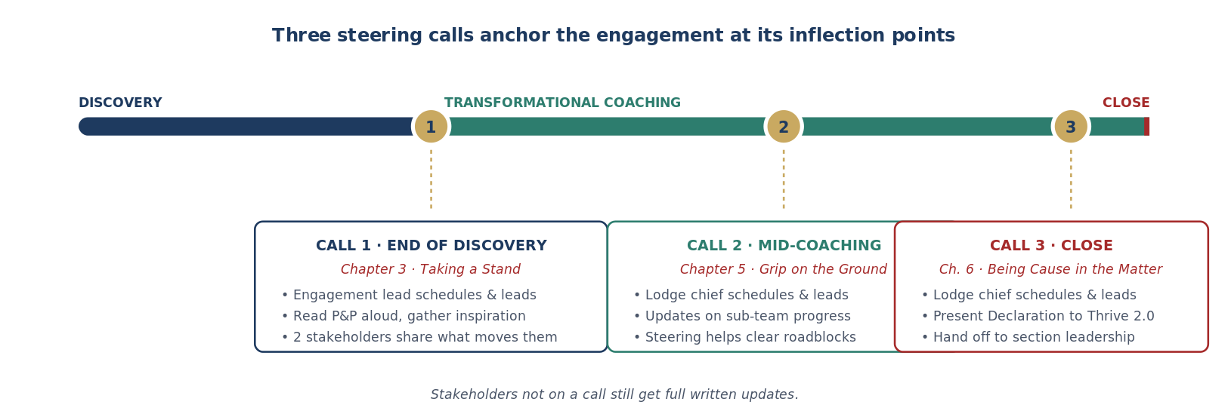
Steering team calls don’t happen often and involve a generally small group of stakeholders. They’re incredibly important. The steering team is the body of stakeholders that are invested in the engagement’s success but aren’t involved in the day-to-day work. These stakeholders should receive periodic updates, occurring approximately three times per engagement, from the working team and provide high-level input for the engagement process. As some of the sponsors behind the engagement, the steering team may also be able to help clear any roadblocks the working team encounters along the way. The steering team comprises the region and section stakeholders, council stakeholders, and Thrive key leadership. While all of these stakeholders are invited to steering team calls, they should
understand that they will still receive comprehensive written updates if they are not on the call.

Steering team calls should take place on the following timeline:
- End of Discovery (Taking a Stand)
- Mid-transformational Coaching (Grip on the Ground)
- Ending the Engagement (Being Cause in the Matter)

The ﬁrst meeting should be scheduled and led by the engagement lead, but the other two need to be scheduled and led by the lodge chief. This is where we lean into their personal growth and development. You’ll want to email the stakeholders and set the stage for the call, most likely send a doodle poll to gain the best time, and schedule the call with a Zoom link. This should be done a couple weeks in advance of the actual call. While the call #2 and #3 focus more on updates and outcomes, call #1 is your chance to help align the group on the lodge’s broader vision. 2 outside stakeholders should be asked to read the possibility & promise and share what inspires them — this will help them buy into the agenda. Let the lodge chief drive the car, but make sure to guide them along the way.

Chapter 4: Something Bigger Than Yourself
Establishing the Sub-Teams
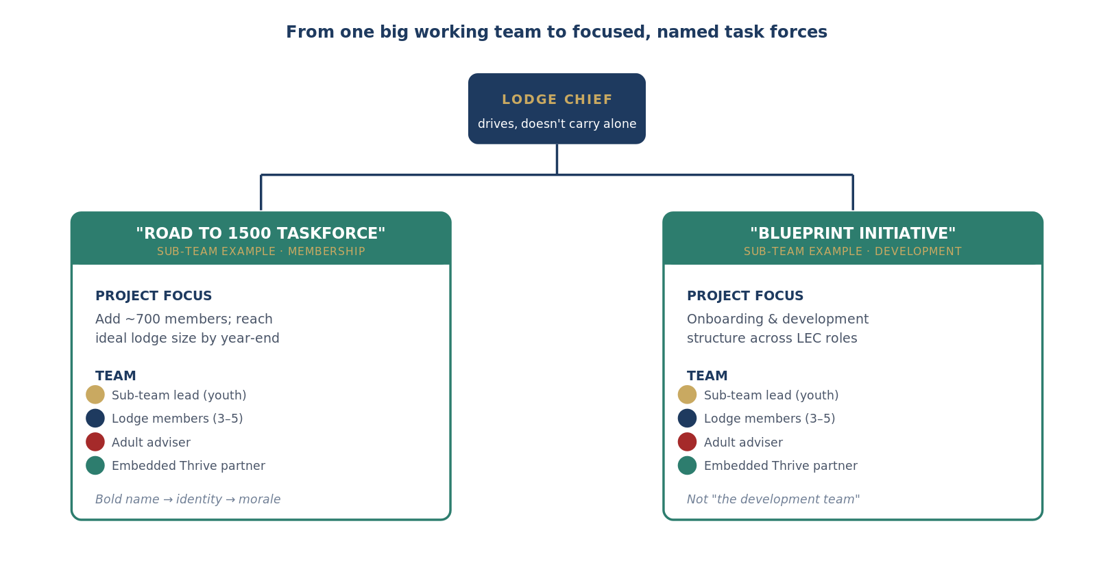
By the time the working team has entered the Transformational Coaching phase, it will have grown substantially in size. Throughout Discovery, your team will have coached the lodge chief on expending their team to include the youth and advisers that should be involved in this engagement, regardless of their status as a lodge ofﬁcer or chairperson - you’ll have helped the lodge chief build the right team.

Given the size of the working team, however, it can become difﬁcult to make meaningful progress in meetings with the full group - there are simply a lot of voices to be heard. At the very beginning of Transformational Coaching, it’s important to have the lodge chief divide the working team (including the Thrive partners) into sub-teams. When the working team aligned on its promise statement, it understood (in broad terms) the projects they intended to complete during the engagement. Take this opportunity to create smaller teams that are focused on a speciﬁc project or two. If the Promise Statement consists of four promises, for example, you may split into two sub-teams that each take half. As a team, you’ll have to identify which projects naturally ﬁt together and should be accomplished by the same small group. The number and composition of sub-teams should be determined by the lodge chief, but heavily inﬂuenced by the coaching of the engagement lead and partners.

You will also want the lodge chief to identify another youth member of their working team to lead each sub-team. In addition to working with and coaching the lodge chief, the Thrive partners should give special attention to these youth. Essentially, we’ll want them to operate as the lead of their sub-team. They (and their project) will beneﬁt from the same week-to-week coaching and follow-ups that your team has been providing to the lodge chief alone throughout Discovery. Throughout the rest of the engagement, most work will happen within sub-teams. You should work with the lodge chief to ensure collaboration occurs across groups, but meeting time is best spent in these breakout conversations.

Much like the lodge itself, youth leaders should feel a distinct attachment to their subteam. People want to be a part of something bigger than themselves. Something bold and inspiring. This is why it is critical that these teams are more than just a group of folks who meet weekly for a coaching session. They deserve to be part of something high impact oriented.

For these reasons, Thrive ’s sub teams are always based on speciﬁc projects, and they always have a creative name associated with each one. For example, in 2020 Thrive worked with Tipisa Lodge in the Central Florida Council. One of the bullet points of their promise statement referred to the lodge embarking on an ambitious membership initiative to gain almost seven hundred members to get back to their ideal size. Was the sub-team referred to as the membership team? Absolutely not — those words are boring and uninspiring. They were the “Road to 1500 Taskforce”. The other sub-team focused on providing a structure for development and continued onboarding across critical positions within their LEC. Were they referred to as the development team? Again — no, for the same reasons. They were part of the “Blueprint Initiative”.

These task forces give lodges a sense of belonging and identity, yes, but the morale they create transcends any data we could ever measure. Once the subteam is staffed, and the name has been created, it’s time for a formal commitment to fulfilling their goals. Teams should lay out a clear roadmap of what the outcomes of the subteam are, and everyone — from lodge leaders to Thrive partners — should commit to shaping this reality.

Remember, we’re only as good as our word.
Enabling the Lodge Chief
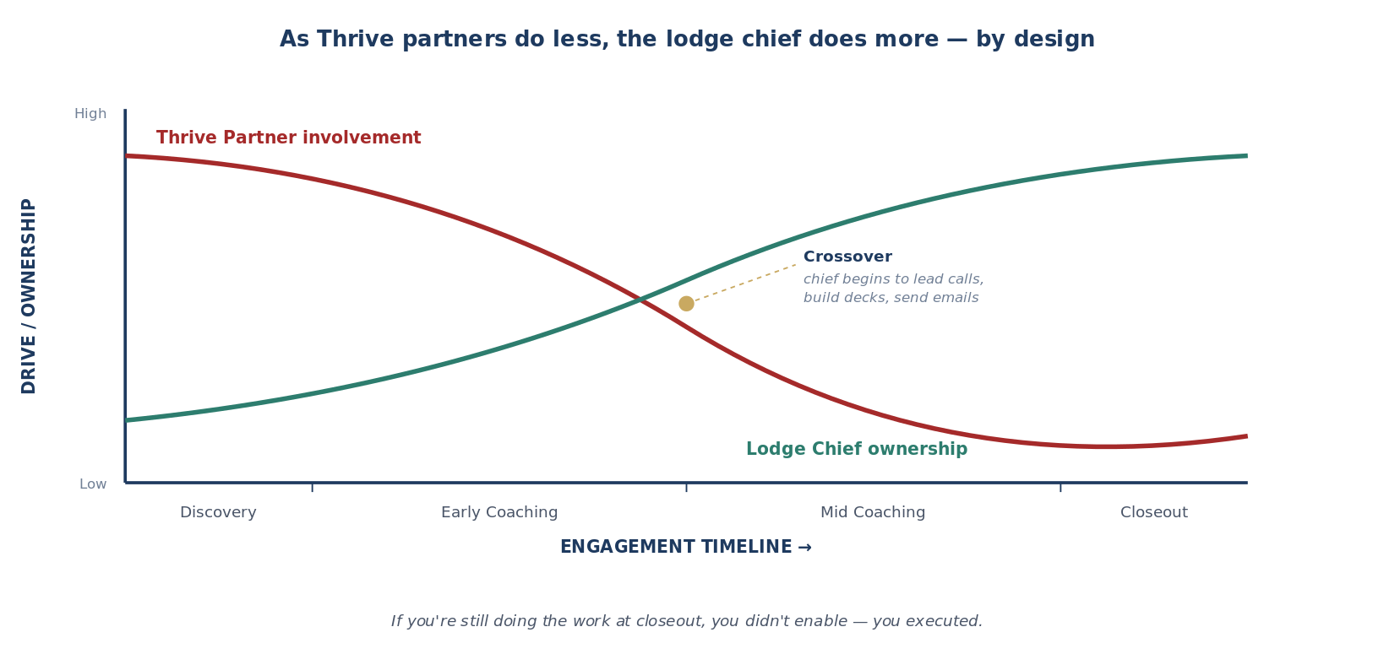
While empowering the lodge to reach high performing status is our focus, this can only be achieved through the enablement of the lodge chief. Someone on the Thrive team must take direct responsibility of that task. Personal development and growth is important and must be inﬂuenced by our team. It is possible that you are walking into a lodge where the youth leaders aren’t overly supported by their adult advisers. Your mentorship could transform someone’s life.

Your role should be signiﬁcantly more hands-on toward the beginning of the engagement, and it’s going to need to be until you've built a foundation of trust. As you make the shift into transformational coaching, you’re going to want to enable the lodge chief to do more. Remember, they (or another lodge leader) will be there long after we are gone. It’s important that they own this process, too.

The lodge chief should begin to work with you to send emails, build slide decks, and lead meetings. They should play an instrumental role in the use of the possibility & promise, asking two of their lodge leaders to read it and share what inspires them at the beginning of each meeting. While things like these seem miniscule compared to the broader goals, our job is to inspire the second century of leadership in the Order of the Arrow, and this is where it matters most. It is also important to recognize that our work must stem beyond just the lodge chief. There is a chance that speciﬁc youth leaders leave their position mid engagement, or are not as engaged as you would like. The lodge, and its success, is larger than just one person. If we want to make systematic changes that have long lasting results, we need to involve a multitude of youth leaders that can carry out this work over the next several years. Look for opportunities to develop those folks as well. It is important to pull in the current lodge leaders, but we need the up and coming youth and adult leaders as well - their personal growth is just as critical to our mission.

Chapter 5: Grip on the Ground
Catalyzing the Breakthrough
Establishing Quick-Wins
Another way to combat the challenges posed by the duration of these projects is to establish quick wins immediately upon entering the Transformational Coaching phase. The projects the lodge has embarked upon will all take months, most likely. However, we should not make them wait months to experience the motivational boost that comes from truly accomplishing something. Within each project, there are likely small but meaningful portions that can be accomplished quickly. Make them a priority, and help the lodge achieve a quick “win” early on to build their conﬁdence and momentum.

Doing Real Work on Calls
It is easy to fall into the trap of using a weekly team meeting to talk about what was supposed to happen since the last call, what you’ll do before the next call, and then hang up. This simply does not do enough to advance an engagement’s projects to completion in the timeframe that we partner with a lodge. Each meeting with the working team should be used to accomplish real outcomes during the meeting. As coaches, we are often hesitant to do this. It seems more natural to let the lodge leaders have their discussion and to follow-up with them after the call. Thrive partners should not shy away from taking an active role in each meeting with the lodge, especially when it drives the completion of a task or project. These lodge leaders need us to be members of their team, not just advisers. This means taking an active role and helping get things done within meetings, in addition to following up between them.

Feel free to use technology to your advantage. Many free tools exist to help you visualize ideas and make substantive progress on each call. For example, Mural is a free software we utilize that allows you to create interactive whiteboards with sticky notes to organize your ideas. Each workstream has their own license— with your Workstream leadership to use yours!

Boosting Morale
This phase of the engagement is a marathon, but we need the working team to sprint most of the way. Over the course of months, it is easy to lose focus, excitement, and determination for the projects the lodge has set out to achieve. To help combat this, lodge leaders need their interactions with Thrive to be fun and fulﬁlling, not just productive or “all business”. One best practice is intentionally making time in each working team meeting to talk about the team members, not the project. For example, you can begin each meeting with a brief “highs and lows” session where everyone shares something about their day or their week. It’s important to place emphasis on everyone’s wellbeing.

Keeping Eyes on the Prize
This phase of the engagement is a marathon, but we need the working team to sprint most of the way. Over the course of months, it is easy to lose focus, excitement, and determination for the projects the lodge has set out to achieve. To help combat this, lodge leaders need their interactions with Thrive to be fun and fulﬁlling, not just productive or “all business”. One best practice is intentionally making time in each working team meeting to talk about the team members, not the project. For example, you can begin each meeting with a brief “highs and lows” session where everyone shares something about their day or their week. It’s important to place emphasis on everyone’s wellbeing.

Chapter 6: Being Cause in the Matter
Shaping the Future
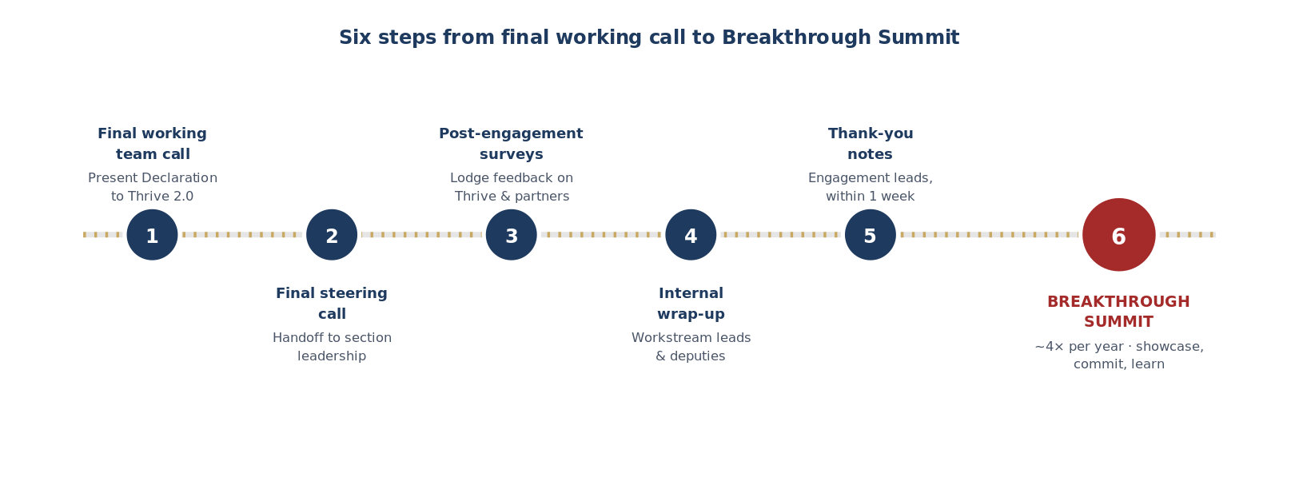
Closing out an engagement is a tough process, you’ve come a long way with your team, and are beginning that rapid descent, your Lodge is able to climb on their own, and as sherpas, you’re gearing up to guide the next Lodge needing your help. In order to ofﬁcially close an engagement, you’ll need to follow the following steps:
- The Engagement Team holds the ﬁnal working team call and presents the Declaration to Thrive 2.0 to be presented at the ﬁnal steering team meeting as the formal transition document.
- Final Steering Call happens, enabling a handoff to the Section Leadership to continue the mentoring process as our partner Lodges move towards achieving their Possibility.
- Lodge Leaders are sent the post engagement surveys for feedback on Thrive and their speciﬁc partners.
- Workstream Leads and Deputies will hold an internal wrap up call to assess how things went from the perspective of the Partners on the engagement.
- Engagement Leads will send thank you notes to the Working Team Stakeholders within one week of the ofﬁcial close out.
- All engagements will be invited to the Breakthrough Summit—a seminar that highlights each engagement’s accomplishments during the current operational cycle.

The engagement transition plan is an attestation of the success of each partnership, setting a framework for the future of the lodge and its development under the tutelage of our section leadership. While the intended audience is the Thrive Steering Team Stakeholders, this can also serve as a helpful guide for other lodges in our section, and for lodges looking for assistance in some of the areas that we struggled with. As a continuation of the Thrive partnership, the extended mentorship is expected to last approximately 1.5-2 years, with the intent of achieving the possibilities set forth during our active engagement. These bold ambitions are achievable on their own, but with continued coaching, support and mentorship from the section leadership, these gains can happen at a much more ambitious pace. The future of the Order of the Arrow—and its lodges—ﬁrmly rest in the adoption of the Thrive Initiative, and the implementation of successful local programming aligned with the methodology of the program. The engagement transition plan outlines the following:
- What the lodge Accomplished: Discovery
- Possibility & Promise Statements
- What the lodge Accomplished: Transformational Coaching
- Sub-team Implementation Plans
- Next Steps: What the Future Holds
- Actionable 2-year plan
- Declaration to Thrive

The Breakthrough Summit serves as the formal “graduation” from the Thrive program. We will aim to execute these ~4 times a year, corresponding to each wave of engagements completing the Transformational Coaching phase. The Breakthrough Summit offers lodge chiefs and their working teams the opportunity to
- showcase their breakthroughs
- commit to implementation post engagement
- learn from the transformation of other lodges with which they shared this experience.

The Breakthrough Summit should be carried out with some degree of formality. It should be hyped up as an exclusive event that lodges earned the right to attend by virtue of completing the Thrive program. It should feature speakers and activities that lend to an air of pomp and circumstance. Partners should hype up the event to the working teams and avoid a perception of it being a “boring” or “passive” ceremony.

Chapter 7: Coaching Guidance
The 5 C’s of Coaching
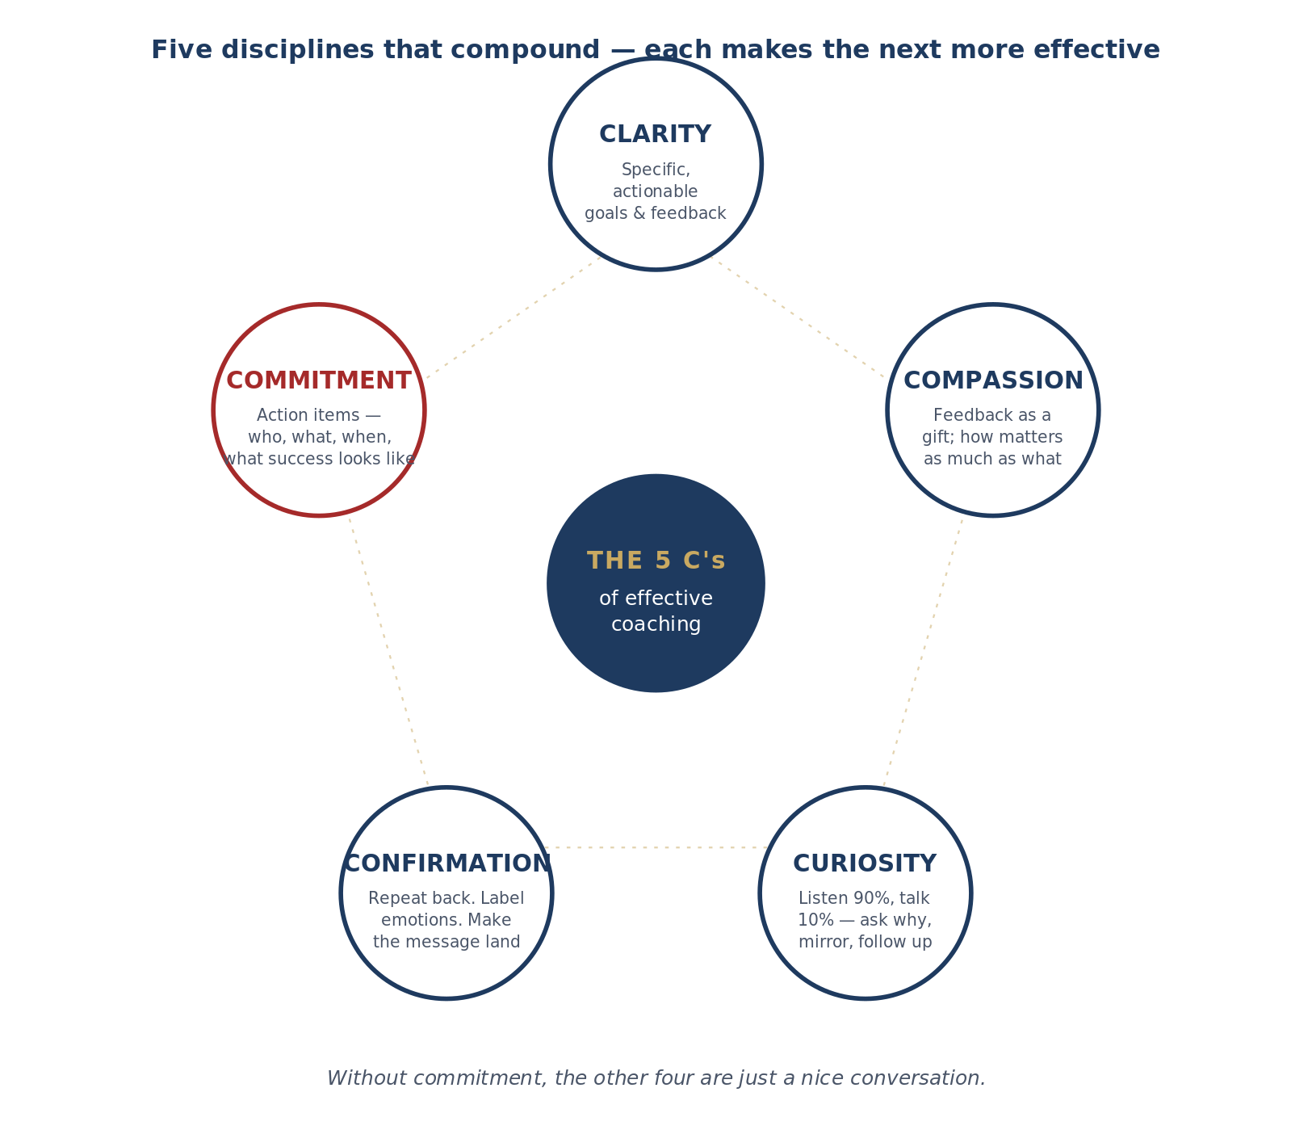
Clarity
We spend the majority of the discovery phase working to clarify the goals of both the lodge and its individual leaders. However, when you are working towards the individual pieces of the P&P statements, you will want to clarify what the goals for today’s meeting are. There are many ways you can do this. Asking the lodge leader(s) to prepare an agenda or to-do list will allow driven youth to communicate their needs and wants directly. However, not every lodge or youth may have the time or self-awareness for that, so you can also take the first 5-10 minutes of the meeting to clarify goals.

Another piece of clarity is specificity. This is especially important when providing feedback or coaching someone to higher performance. Feedback given poorly can crush anyone’s spirit. Giving specific ACTIONABLE feedback rather than a loose complaint is more likely to allow growth and understanding. For example: “you need to be more confident” is not nearly as helpful as “Your posture and intonation made it sound like you didn’t have confidence in what you were saying.”

Compassion
As we know feedback can be hard to give and receive. Some coaches are conflict avoidant or simply want to be liked and that can make giving feedback all the harder. To stay an effective coach it is important to practice compassion towards ourselves. This allows us to acknowledge the fears or concerns we may have and get ourselves out of the way.

Compassion towards the person we are providing feedback to is equally as vital. In DYLC, there is a session about the difference one caring adult can make. While you may or may not be an adult, you may be the one caring person to make an impact on whomever you are coaching. We must foster an environment of caring. How we say something is just as important (if not more so) than what we say. Some things that you can do to foster that environment and set the right tone are:
- Start the conversation with a conversation about the expectations and feelings everyone might have about feedback. Feedback should be intended as a gift.
- While you are giving feedback, pretend you are giving it to your best friend for whom you want nothing but the best.
- Be sure to say that you are both working towards the same goal of helping them reach their full potential.
- Being vulnerable can foster the culture of trust and compassion. Don’t be afraid to mention it if you are uncomfortable or unsure about providing feedback.
- At the end of any conversation ask how you can support them or what they need from you to accomplish their goals.

Curiosity
Coaching involves more listening than talking. Typically you want to listen 90% of the time and talk only the other 10%. This typically means asking lots of guiding questions meant to make the person think. When come from a place of curiosity and not judgement, new insights can appear and solutions can be co-created to help us gather more commitment.
Some tips for listening curiously are:
- Ask why. There is a technique called the 5 Whys that basically says if you ask why repeatedly (in this case 5 times) you will get to the root cause of a problem or emotion. Be aware that this can be extremely frustrating for the person you are talking to, so you may want to explain to them what you are doing.
- Mirroring. Most people love to talk, especially about themselves and the issues they are having. If you would like to hear more about something that is currently being discussed without adding anything of your own, simply repeat the last couple words the person said back to them. It might not always work, but often they will begin elaborating.

Confirmation
Communication in an ideal world is a two-way dynamic process between a sender and a receiver, and the message the receiver hears can be garbled by noise (literal or metaphorical). In this case the noise is frequently emotional. When emotions are involved in a conversation (coaching involves A LOT of emotions), it can be hard to listen clearly. So it is important to seek confirmation that you are both on the same page. Ask questions. Pay attention to not just what is being said but what body language is telling you. Often what our words mean can be completely changed by whether we are smiling or frowning. One way you can confirm you are hearing their message correctly is to repeat back what you are hearing from them. “I hear you are saying X. Am I understanding you correctly?”

You can also confirm emotions. Labeling is a powerful tool. When you tell a person what it feels/seems/sounds/ like they are feeling, they are forced to confront that feeling. It can be extremely validating if done correctly. I can also help bring someone back from an amygdala hijack, when an intense emotional reaction (frequently panic or anger) overrides the logical part of the brain.

Commitment
The end goal of everything we do in Thrive is to help others become better versions of themselves. For that we need clear commitment and strengthened trust in the relationship. The P&P Statement is a perfect example of commitment, and you can make similar agreements on a smaller scale by asking questions like:
- What are your most important takeaways from this conversation?
- What are follow-up action items that are important, by whom and by when?
- What will it look like when these actions are taken?
- What does success look like to you?
- What are some ways we want to keep track of progress?

