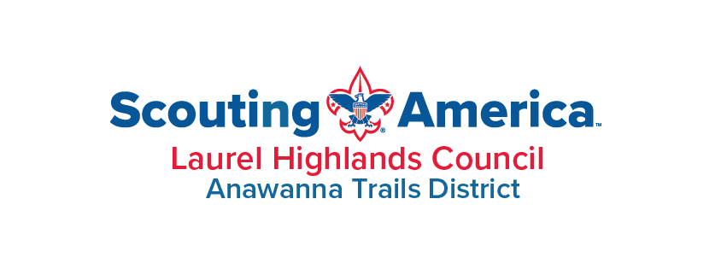
COMPREHENSIVE DISTRICT OPERATIONS ANALYSIS
District Chairman Transition Briefing
Anawanna Trails District 13
Laurel Highlands Council 527 · Scouting America
April 2026
Prepared for the Incoming District Chairman

Executive Summary
431  Registered Youth (Mar 2026) | 23  Active Units | 28  Eagle Scouts 2025–26 (Record) | 7,163  Service Hours (6-Year Total)

Anawanna Trails District 13 of Laurel Highlands Council 527 enters spring 2026 at a critical inflection point. Following a strong post-pandemic recovery that reached a five-year membership peak of 561 registered youth in March 2025, the district has experienced a significant reversal across virtually every performance metric. This consolidated report synthesizes eight analytical areas — membership, retention, total youth served, geographic distribution, advancement, leader training, service hours, and the Order of the Arrow — to provide an integrated picture for the incoming District Chairman.

−24%  Youth Membership YOY (2025→2026) | 59%  Leaders Trained (Target 70%) | 28  Eagle Scouts 2025–26 | −41%  Service Hours 2024→2025

Headline Findings
Membership has declined sharply from the 2025 peak (561 youth) to approximately 431 youth in March 2026 — a 24% single-year drop affecting both Cub Scouts (318→255) and Scouts BSA (243→176). Six units confirmed closure between 2025 and 2026, including both of the district's girls' Scouts BSA troops, eliminating the entire girls' troop program. The district now operates 23 active units, down from a high of 29.
Youth retention has declined for four consecutive years, from a post-pandemic high of 79.6% in December 2022 to 70.6% in December 2025 — barely at Scouting America's Journey to Excellence threshold. The mid-cycle March 2026 snapshot of 58.1% is a warning indicator requiring close monitoring. Five Cub Scout packs report retention rates below 50%, with Pack 1005 (30%) and Pack 1315 (31%) representing the most acute emergencies.
Total Youth Served (TYS) — Scouting's measure of full community reach — fell from 652 (2024) to 616 (2025) to 505 year-to-date in 2026. The 2026 YTD rate of decline (−18% vs. the same April calendar point in 2025) is more than three times the prior year's rate (−5.5%). The youngest age cohort (grades K–2) is down 36% since 2024 — a structural pipeline crisis that will affect Scouts BSA enrollment by the early 2030s if left unaddressed.
Despite these challenges, several bright spots stand out. The district produced a record 28 Eagle Scouts in 2025–26, led by Troop 1313's extraordinary output of 10 Eagles. Troop 1005 logged an exceptional 552 service hours in 2025 and achieved 83% youth retention with strong year-over-year growth. Troop 1351 (Burgettstown) emerged as a new unit, tied for the top retention rate at 83%. Pack 1305 and Troop 1305 both maintain 100% leader training — the district's only units at gold standard. The Order of the Arrow saw its best-ever Brotherhood completion year in 2025 (11 completions) and has expanded unit participation from 3 to 8 units over five years.

The Most Urgent Issue: YPT Mass Expiration
⚠ IMMEDIATE ACTION REQUIRED — Before June 1, 2026
118 of the district's 205 registered adults (57.6%) have Youth Protection Training (YPT) expiring simultaneously on May 31, 2026 — only 46 days from the report date. Any adult with expired YPT may not participate in Scouting activities. A district-wide personal outreach campaign must begin immediately. Units most at risk: Troop 1313 (12 expiring), Troop 1017 (8 expiring), Pack 1305 (7 expiring).

Cross-Cutting Strategic Priorities
The following priorities are drawn from across all eight analytical areas and represent the highest-leverage actions available to incoming district leadership:
- Immediate: Launch YPT mass renewal campaign before May 31, 2026 deadline.
- Immediate: Conduct retention interventions with Pack 1315 and Pack 1005 (sub-35% member retention).
- Immediate: Assess Troop 1280 (Waynesburg) — only 3 youth, 20% training, near-zero service.
- Fall, 2026: Develop a Webelos-to-Scouts-BSA crossover initiative; combined Webelos + AOL pipeline fell 17% (105 → 87).
- Fall, 2026: Coordinate Fall 2026 K–2 recruiting campaign across all packs.
- Near-Term: Expand girls' Scouts BSA program — currently only one Girls’ Troop is active in Canonsburg, PA.
- Near-Term: Move district leader training rate from 59% to 70% by year-end 2026.
- Near-Term: Develop a Greene County multi-year recovery strategy.

Table of Contents
Executive Summary 2
Headline Findings 2
The Most Urgent Issue: YPT Mass Expiration 3
Cross-Cutting Strategic Priorities 3
Table of Contents 4
1. Membership Analysis 6
1.1 Five-Year Membership Overview 6
1.2 Cub Scout Program — Program Breakdown 7
1.3 Scouts BSA Program 8
1.4 Unit Health Snapshot 8
Cub Scout Packs 9
Scouts BSA Troops 9
1.5 Priorities for Incoming District Chairman 9
Immediate (2026) 9
Near-Term (2026–2027) 9
2. Youth Retention Analysis 10
2.1 District Retention Rate Trend (2020–2026) 10
2.2 Unit-Level Retention Rates (April 2026) 11
2.3 Units of Greatest Concern 11
2.4 Priorities for Incoming District Chairman 12
3. Total Youth Served 13
3.1 Annual TYS Overview 13
3.2 Geographic Distribution 14
3.3 Youth Pipeline by Grade Band 15
3.4 TYS vs. Registered Membership 15
3.5 Priorities for Incoming District Chairman 15
4. Geographic Analysis 17
4.1 Community-by-Community Overview 17
4.2 Washington City (15301) — The Cub Crisis and Troop Strength 18
4.3 Peters Township / McMurray (15317) — Cub Strength, Troop Gap 18
4.4 Burgettstown (15021) — An Emerging Success 18
4.5 Greene County — A District Within a District 19
4.6 Communities with Lost Coverage 19
4.7 Geographic Strategic Priorities 19
Immediate (0–6 months) 19
Near-Term (6–18 months) 19
Long-Term (18+ months) 20
5. Advancement Analysis 21
5.1 Scouts BSA Advancement Overview 21
5.2 Eagle Scout Production by Unit 22
5.3 Cub Scout Advancement 22
5.4 Priorities for Incoming District Chairman 23
6. Leader Training Analysis 24
6.1 District Training Status Summary 24
6.2 Unit-by-Unit Training Rates 25
6.3 YPT Expiration Details 26
6.4 Priorities for Incoming District Chairman 26
Immediate Actions (Before June 1, 2026) 26
Near-Term (Q2–3 2026) 26
7. Service Hours Analysis 27
7.1 Annual Service Hours Trend 27
7.2 Key Unit Service Performance 28
7.3 Service Categories 28
7.4 Priorities for Incoming District Chairman 29
Appendix — Data Sources 30

1. Membership Analysis
Anawanna Trails District 13 has demonstrated a generally upward membership trajectory following COVID-19 disruptions, achieving a five-year high of 561 registered youth in March 2025. However, early 2026 data reveal a significant reversal.

1.1 Five-Year Membership Overview
District youth membership as captured in March of each program year provides a consistent annual benchmark across both major youth programs.
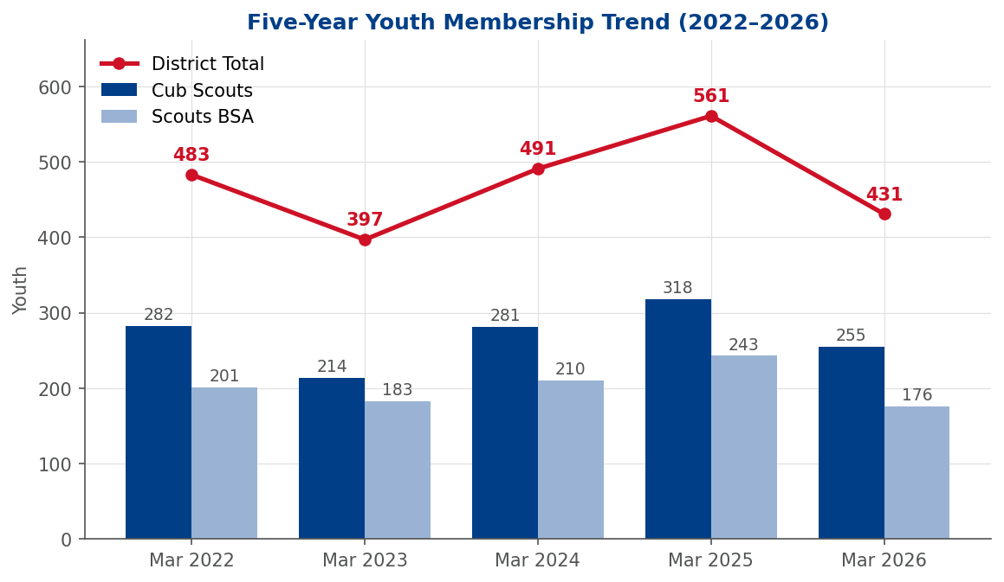
Figure 1.1 — Five-Year Youth Membership Trend: Cub Scouts, Scouts BSA, and District Total (2022–2026)
Year | Cub Scouts | Pack Units | Scouts BSA | Troop Units | District Total
Mar 2022 | 282 | 12 | 201 | 16 | 483
Mar 2023 | 214 | 8 | 183 | 14 | 397
Mar 2024 | 281 | 11 | 210 | 18 | 491
Mar 2025 | 318 | 11 | 243 | 18 | 561
Mar 2026 | 255 | 10 | 176 | 13 | 431
District membership reached its lowest point in March 2023 (397 youth), falling 18% from the prior year. The district responded effectively: a rebound to 491 in 2024 and a surge to 561 in 2025 demonstrated focused recruiting and effective crossover programming. The 2026 decline to 431 breaks this growth trend — the largest single-year decline in raw numbers (−130) and percentage terms (−24%) in the five-year window.

1.2 Cub Scout Program — Program Breakdown
The Cub Scout program represents the primary entry point for youth and is the critical feeder system for Scouts BSA. After bottoming out at 214 in March 2023, Cubs mounted a strong recovery to 318 in March 2025 — its five-year high. The 2026 data introduce concern across all rank levels.
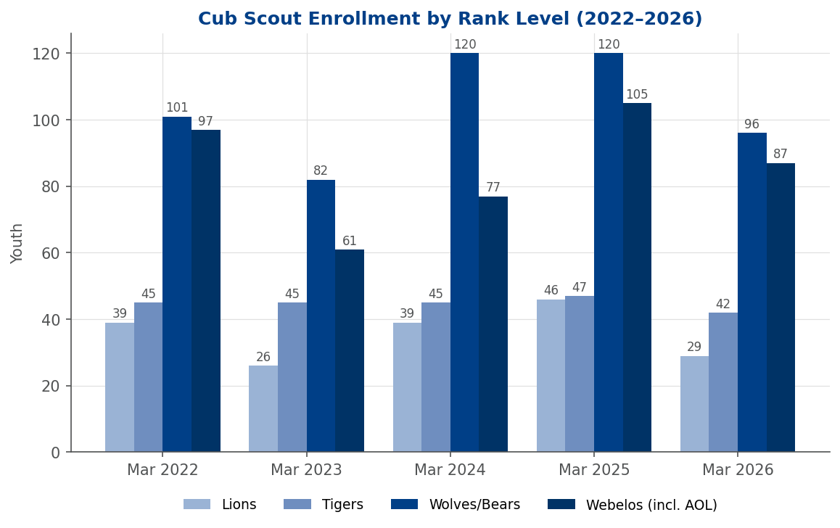
Figure 1.2 — Cub Scout Enrollment by Rank Level (2022–2026)
Year | Lions | Tigers | Wolves/Bears | Webelos (incl. AOL) | Cub Total
Mar 2022 | 39 | 45 | 101 | 97 | 282
Mar 2023 | 26 | 45 | 82 | 61 | 214
Mar 2024 | 39 | 45 | 120 | 77 | 281
Mar 2025 | 46 | 47 | 120 | 105 | 318
Mar 2026 | 29 | 42 | 96 | 87 | 254
Webelos column includes Arrow of Light (AOL) scouts for every year. OLR added Arrow of Light as a separately tracked subprogram in the March 2026 Membership-by-Month report; the Mar 2024 and Mar 2025 reports return zero AOL rows because the category did not exist at those snapshots (AOL-rank-holding 5th-grade Cubs were classified as Webelos). For trend continuity across all five years, the Mar 2026 Webelos figure of 87 combines the 62 reported Webelos and 25 reported AOL scouts. Mar 2026 subprogram rows sum to 254; the 255 Cub Total in Section 1.1 reflects the source's top-line figure (a 1-scout rounding/categorization variance inherited from the report).

The combined Webelos + Arrow of Light cohort (the AOL-eligible 5th-grade pipeline) declined 17% in a single year — from 105 in March 2025 to 87 in March 2026 (62 reported as Webelos plus 25 reported as AOL under the new OLR category). These are the Scouts in the final stage before crossing over to Scouts BSA, and this contraction signals a smaller 2026–27 crossover class, creating downstream Scouts BSA membership reduction.
Red Flag — Cub Scout Program
Pack 1315 has dropped from 48 youth (2022) to 24 (2026), losing half its enrollment with no recovery year. Pack 1350 is confirmed closed. The combined Webelos + Arrow of Light cohort declined 17% from 2025 (105) to 2026 (87), foreshadowing a smaller 2026–27 crossover class.

1.3 Scouts BSA Program
Scouts BSA membership peaked at 243 across 18 troops in 2025. The 2026 decline to 176 across 13 troops represents a 28% drop in youth membership and a loss of five troop charters. Confirmed closures include Troop 1103 (Boys), Troop 9191 (Girls), and Troop 9280 (Girls).
While at first glance it appears that Troop 1005 shows a remarkable turnaround — up 144% versus the same month last year (22 youth)—it should be noted that this growth was primarily driven by the absorption of Scouts from Troops 1103 and 1031. Troop 1305 (Girls) has been a consistent performer, growing from 6 in 2022 to 12 in 2026. However, it should be noted that right now they are the only Scouts BSA Troop for girls in the District and no other alternative exists. Troop 1351 (Burgettstown) is new to this reporting cycle and already tied for top retention rate at 83%. These units represent best practices worth studying and replicating.
Red Flag — Scouts BSA Program
Both girls' Scouts BSA troops (9191 and 9280) confirmed closed, leaving zero girls' troop presence in the district. Troop 1103 (Boys) also closed, removing a historically reliable Eagle producer. Net loss: five troop charters in one recharter cycle (18 → 13 active troops).

1.4 Unit Health Snapshot
Highlighted units below are representative of the district's range of trajectories — high-growth, stable, declining, and at-risk — across both programs. Tables are split by program type (Cub Scout packs and Scouts BSA troops) so that comparisons stay within program.

Cub Scout Packs
Pack | Mar 2022 | Mar 2024 | Mar 2026 | 5-yr Change | Status
Pack 1305 | 62 | 64 | 68 | +6 | Strong
Pack 1313 | 33 | 48 | 42 | +9 | Strong
Pack 1280 | 7 | 4 | 13 | +6 | Growing
Pack 1017 | 50 | 37 | 31 | −19 | Declining
Pack 1315 | 48 | 36 | 24 | −24 | At Risk

Scouts BSA Troops
Troop | Mar 2022 | Mar 2024 | Mar 2026 | 5-yr Change | Status
Troop 1005 | 14 | 16 | 22 | +8 | Strong
Troop 1305 (G) | 6 | 7 | 12 | +6 | Growing
Troop 1351 | — | 2 | 6 | +4 (new) | Emerging
Troop 1313 | 40 | 33 | 31 | −9 | Declining
Troop 1280 | 14 | 7 | 3 | −11 | At Risk

1.5 Priorities for Incoming District Chairman

Immediate (2026)
- Work with the District Commissioner and unit commissioners to conduct a unit viability assessment for packs and troops showing membership of 5-7 Scouts, with a clear plan: support, merge, or formally close.
- Establish a Webelos-to-Scouts-BSA crossover plan for 2026, given the 17% decline in the combined Webelos + AOL pipeline (105 → 87). Coordinate with Pack 1305, Pack 1313, and Pack 1396.
- Monitor December 2026 retention rate. A rate below 70% would trigger the need for a formal retention initiative.

Near-Term (2026–2027)
- Prioritize expansion of girls' Scouts BSA program — currently only one Girls’ Troop is active in Canonsburg, PA.
- Identify two to three new charter organizations to replace the six units lost between 2022 and 2026.

2. Youth Retention Analysis
Recruiting a new Scout costs roughly five to ten times the effort of retaining one already in the program. Yet retention is often treated as a passive outcome rather than an active priority. Scouting America's Journey to Excellence (JTE) gold standard is 80%; the threshold for JTE credit is 70%.

2.1 District Retention Rate Trend (2020–2026)
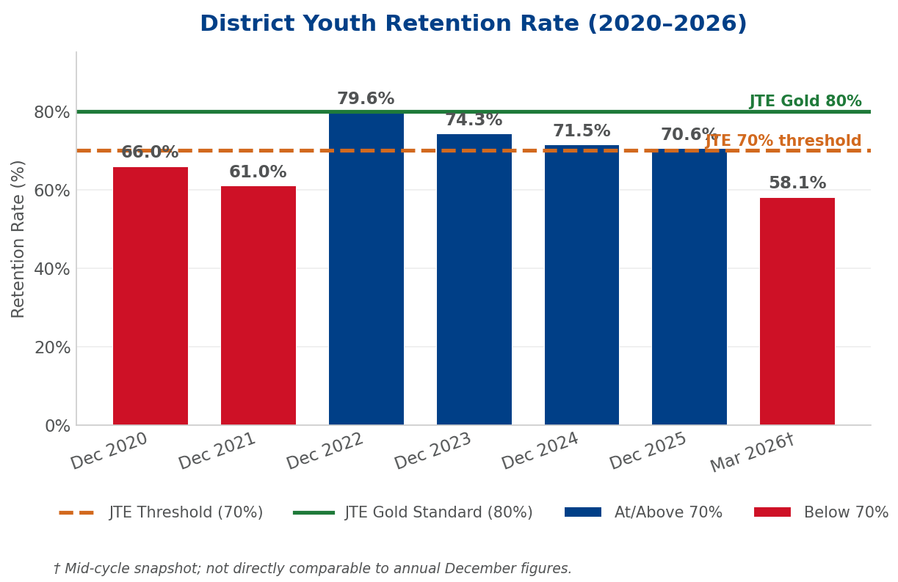
Figure 2.1 — District Youth Retention Rate (2020–2026) with JTE Benchmarks
Period | Retention Rate | Youth Retained | Eligible Youth | YOY Change (pts)
Dec 2020 | 66.0% | 634 | 961 | —
Dec 2021 | 61.0% | 442 | 725 | −5.0 pts
Dec 2022 | 79.6% | 457 | 574 | +18.6 pts
Dec 2023 | 74.3% | 410 | 552 | −5.3 pts
Dec 2024 | 71.5% | 366 | 512 | −2.8 pts
Dec 2025 | 70.6% | 339 | 480 | −0.9 pts
Mar 2026 (mid-yr) | 58.1% | 299 | 515 | — (snapshot)
The district has not been able to sustain the 79.6% peak of December 2022, losing 9 percentage points over three recharter cycles. Equally concerning is the contraction of the eligible youth pool from 961 (December 2020) to 480 (December 2025) — a 50% collapse in the baseline of youth who could be retained.

2.2 Unit-Level Retention Rates (April 2026)
There is significant variation across units. Four units report 100% retention (Pack 1280, Troop 1168, Troop 1280, Troop 1320), though these are all small units. Among larger units, Troop 1005 and Troop 1351 lead at 83%. Five packs report below 50% retention.
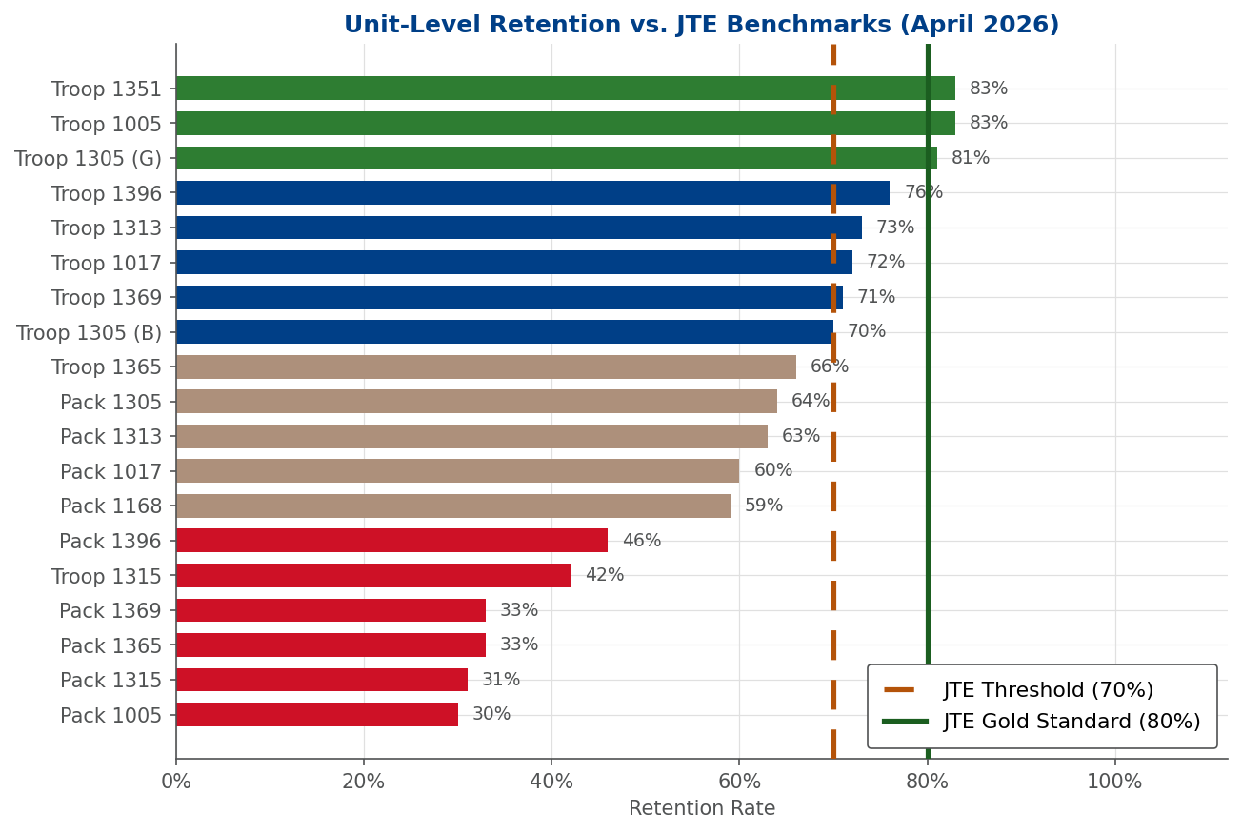
Figure 2.2 — Unit Retention Rates vs. JTE Benchmarks (April 2026)
Note: Thresholds are from the retired JTE program.
Thresholds being used as benchmarks for this document only.

2.3 Units of Greatest Concern
Unit | Retention | YOY Change | Assessment
Pack 1005 | 30% | −3 youth | Critical — may not sustain without aggressive recruitment
Pack 1315 | 31% | −11 youth | Most urgent: 5-yr decline 48→24 with no recovery year
Pack 1365 | 33% | 0 net | Revolving door — recruiting but not retaining
Pack 1369 | 33% | −4 youth | Program engagement issues; declining trend
Troop 1005 | 83% | +13 youth | District model — study and replicate
Troop 1305 (G) | 81% | +1 youth | Consistent builder since program launch

2.4 Priorities for Incoming District Chairman
- Conduct retention intervention visits with Pack 1315 and Pack 1005 — the two most urgent cases.
- Investigate Pack 1315's leadership situation; 5-year enrollment collapse from 48 to 24.
- Place Troop 1280 on an active watch list (79% five-year membership loss).
- Establish retention as a standing metric in every unit Key 3 conversation; trigger a formal support plan for any unit below 60%.
- Study and share the Troop 1005 model — 83% retention plus +13 absolute growth is exceptional; Troop 1351 offers a complementary small-unit model.
- Build a "Graduation Pipeline" program for Webelos-to-Scout crossover to reduce the largest single attrition point.

3. Total Youth Served
Total Youth Served (TYS) is Scouting America's primary measure of community reach, capturing registered youth plus participants in merit badge fairs, service events, and program-adjacent activities. TYS in this district consistently exceeds registered membership by approximately 50 youth annually.
All TYS figures in this section reflect the Anawanna Trails District boundary; participants from areas outside the district that appeared in the source reports have been excluded. Grade-band and gender counts are proportionally adjusted from source totals because ZIP-level breakdowns are not available for those dimensions.

3.1 Annual TYS Overview
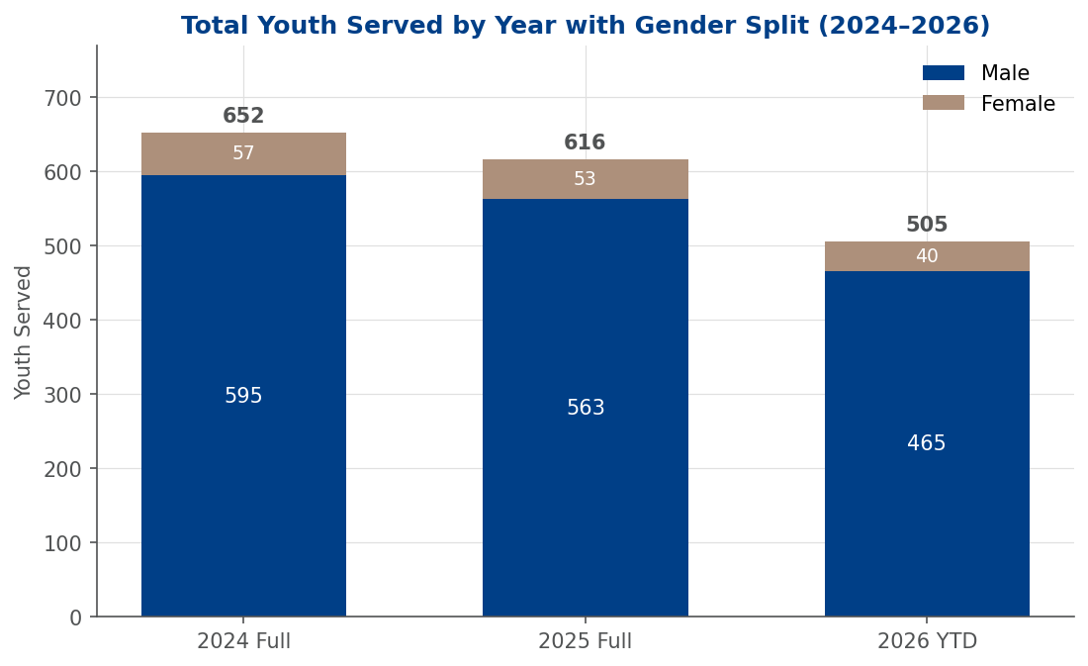
Figure 3.1 — Total Youth Served by Year and Gender, district-only (2024–2026)
Year | TYS Total | Male | Female | Female % | YOY Change | YOY %
2024 (full year) | 652 | 595 | 57 | 8.7% | — | —
2025 (full year) | 616 | 563 | 53 | 8.6% | −36 | −5.5%
2026 YTD (Apr) | 505 | 465 | 40 | 7.9% | −111 | −18.0%

The 2025–2026 YTD decline of 111 youth (−18.0%) at the same April calendar point is more than three times the prior year's rate of decline (−5.5%) and represents the net effect of multiple unit closures combined with declining pack enrollment. Female participation (7.9%) remains stubbornly low despite girls' program launch, and is now structurally constrained to Troop 1305 (G) — the district's only remaining active girls' Scouts BSA troop.

3.2 Geographic Distribution
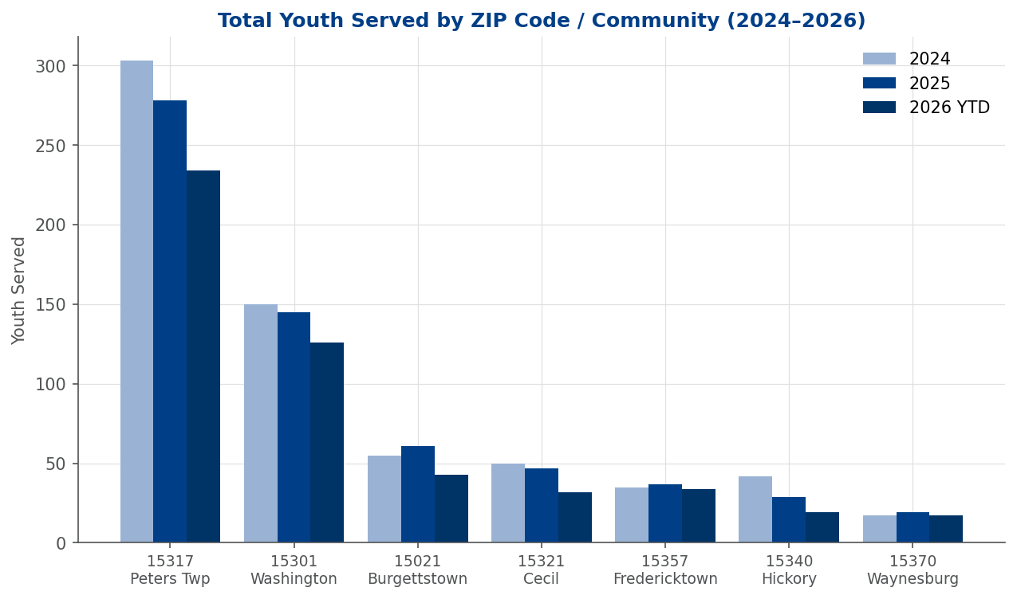
Figure 3.2 — Total Youth Served by ZIP Code / Community, district-only (2024–2026)
ZIP 15317 (Canonsburg/Peters Township) dominates with 45.1% of all 2025 district youth served (278 of 616). Canonsburg/Peters and Washington (15301) together account for 423 of the 616 youth served in 2025 — 69% from two ZIP codes. The steepest year-over-year contraction is in ZIP 15340 (Hickory), which declined from 42 (2024) to 19 (2026 YTD) — a 55% drop in two years. Cecil Township (15321) is also contracting more sharply than the district average. The district's geographic reach is consolidating toward its Washington–Peters corridor.

3.3 Youth Pipeline by Grade Band
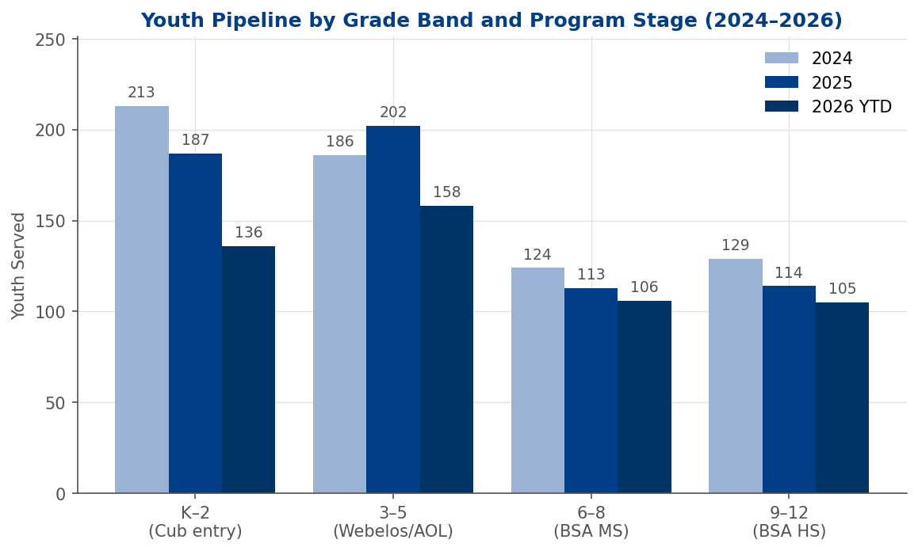
Figure 3.3 — Youth Pipeline by Grade Band and Program Stage (2024–2026)
The sharpest decline is in the grades K–2 entry cohort — the foundational segment that produces Webelos and eventually Scouts BSA enrollment five years out. This group fell from 213 (2024) to 187 (2025) to 136 (2026 YTD), a cumulative 36% loss. Without rebuilding this cohort, the district will face a structural enrollment gap in BSA programs by the early 2030s.

3.4 TYS vs. Registered Membership
TYS consistently exceeds registered youth membership by approximately 50 youth annually. In 2025, with 616 TYS and ~566 registered youth, the difference of ~50 represents community participants without formal registration. Converting even a fraction of this unregistered cohort into members is among the most efficient membership growth strategies available.

3.5 Priorities for Incoming District Chairman
- Prioritize K–2 recruiting for Fall 2026; every pack needs a concrete kindergarten-through-2nd-grade recruiting plan to rebuild the 136-youth K–2 cohort.
- Develop a Webelos Pipeline Initiative for 2026–2027 — the 158 youth in grades 3–5 are the district's most valuable near-term BSA recruitment asset.
- Investigate the steep ZIP 15340 (Hickory) contraction — 42 → 19 youth served in two years, far above the district-wide rate of decline.
- Convert the TYS gap into membership through post-event follow-up protocols at merit badge fairs and day camp.
- Set a geographic expansion target for 15301 (Washington) and 15321 (Cecil Township).
- Grow female participation toward 10% of TYS by establishing at least one additional girls' BSA troop.

4. Geographic Analysis
Anawanna Trails District 13 spans Washington County and Greene County, Pennsylvania, and at its peak contained Scouting units in eleven distinct ZIP codes. As of March 2026, only seven retain active units. The district's 431 registered youth are heavily concentrated in a single northeast corridor running from Washington city through Peters Township.

4.1 Community-by-Community Overview
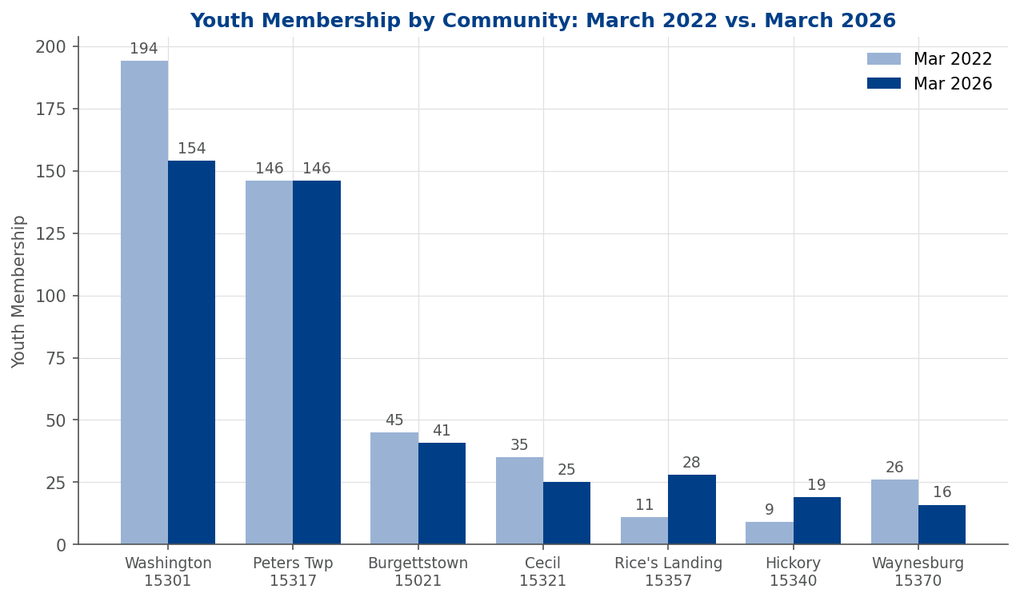
Figure 4.1 — Youth Membership by Community: March 2022 vs. March 2026
ZIP / Community | County | Active Units | Mar 2022 | Mar 2026 | Status
15301 — Washington | Washington | 8 | 194 | 154 | Strong
15317 — Canonsburg/Peters Twp | Washington | 4 | 146 | 146 | Strong
15021 — Burgettstown | Washington | 3 | 45 | 41 | Stable
15321 — Cecil | Washington | 2 | 35 | 25 | Stable
15357 — Rice's Landing | Greene | 2 | 11 | 28 | Growing
15340 — Hickory | Washington | 2 | 9 | 19 | At Risk
15370 — Waynesburg | Greene | 2 | 26 | 16 | At Risk
15323 — Claysville | Washington | 0 | 8 | — | No Coverage
The two strongest communities — Washington (15301) and Peters Township (15317) — together account for 300 of the district's 429 active youth (70%). This concentration is both a strength and a vulnerability: structural problems in either area would be catastrophic for the district total.

4.2 Washington City (15301) — The Cub Decline and Troop Strength
Washington carries the largest single-community roster (154 active youth across 8 units) but presents a contradictory picture. The Cub Scout side is in sharp decline: Pack 1005 (30% retention), Pack 1017 (declined 50→31 over 5 years), and Pack 1315 (31% retention, 48→24 in 5 years). These packs are the feeder system for Washington's troops, and their decline will be felt in troop enrollment within two to three recharter cycles.
Conversely, Washington's troops are genuinely succeeding: Troop 1005 grew from 14 to 22 scouts (+57%), Troop 1017 from 13 to 20 (+54%), and Troop 1305 Girls from 6 to 12 (+100%). Washington is also the location of Pack 1103 and Troop 1103, both confirmed closed, representing three units removed from the community.

4.3 Peters Township / McMurray (15317) — Cub Strength, Troop Gap
ZIP 15317 is the highest-volume community, anchored by Pack 1305 — the district's largest single unit at 68 youth. However, the Scouts BSA side lags badly: Pack 1305 (68) and Pack 1313 (42) together produce 110 Cub Scouts, but Troop 1313 holds just 31 scouts and is declining. Troop 1320 has dwindled to 5 youth and is at risk of closure. Critically, ZIP 15317 has never sustained a girls' troop despite two large family-style Packs enrolling girls at the Cub level.

4.4 Burgettstown (15021) — Cautious Optimism
Burgettstown is the district's most encouraging story in western Washington County. Pack 1396 has been the community anchor (24→25 youth), and the emergence of Troop 1351 is notable — this unit did not exist in the 2022 data and has grown to 6 scouts by 2026, earning an 83% retention rate tied for top in the district. Pack 1350 closed (confirmed), but the remaining three units demonstrate the community can support Scouting. Troop 1396, while declining (15→10), still operates; leadership stability here is the key priority.

4.5 Greene County — Greatest Opportunity and Challenge
Greene County represents the southern half of the district's geography but contributes only 44 youth across four active units — roughly 10% of district membership from half its land area. Three of five historically active ZIP codes now have zero Scouting presence. Without intervention, Greene County will lose its remaining Scouting program within the next recharter cycle or two.
The notable exception is Rice's Landing (15357), where Pack 1168 has grown 171% (7→19 youth) and Troop 1168 has grown from 4 to 9 scouts. These units should be treated as the foundation for any Greene County recovery strategy. Waynesburg (15370), the county seat, presents the opposite story: Troop 9280 (Girls) confirmed closed, and Troop 1280 (Boys) has collapsed from 14 scouts to just 3.

4.6 Communities with Lost Coverage
Community | ZIP | Last Unit | Recovery Potential
Claysville, PA | 15323 | Troop 1031 | Moderate — school district may have interest
Houston, PA | 15342 | Troop 1378 (2025) | Moderate — Houston SD as potential partner
Carmichaels, PA | 15320 | Troop 1262 (inactive) | Low — needs charter org partner in Greene County
Eighty Four, PA | 15330 | Troop 1300 (unactivated) | Low — never activated; needs full unit start

4.7 Geographic Strategic Priorities

Immediate (0–6 months)
- Waynesburg / Troop 1280 unit assessment — 3 scouts, ≤20% training; likely within one departure from collapse.
- Washington Pack retention intervention — Pack 1005 and Pack 1315 at 30–31% retention.
- Peters Twp girls' troop gap — work with Pack 1305 and Pack 1313 to identify a chartering organization.

Near-Term (6–18 months)
- Troop 1320 (McMurray) stabilization — at 5 scouts and ≤20% trained; consolidation with Troop 1313 should be considered if it cannot recruit 3–5 new scouts from crossovers.
- Claysville and Houston unit restarts — both had functioning units as recently as 2025; Pack-first strategy recommended.
- Rice's Landing leadership succession planning — Pack 1168 and Troop 1168's remarkable Greene County growth must be protected.
- Troop 1351 / Burgettstown training investment — the district's newest troop; support its 83% retention with Scoutmaster training before growth stalls.

Long-Term (18+ months)
- Develop a multi-year Greene County recovery strategy with council partnership, targeting Waynesburg and Carmichaels civic organizations.
- Evaluate Washington Pack consolidation if Pack 1005 and Pack 1315 retention continues to deteriorate.

5. Advancement Analysis
Advancement — the progression of youth through ranks and awards — is a fundamental measure of program quality. Across Anawanna Trails District 13 over the three program years from 2023–24 through 2025–26, the advancement picture shows substantial strength in Scouts BSA and mixed results in Cub Scouts, with an exceptional Eagle Scout output in the most recent year.
Note: The 2022–23 BSA program year and Cub Scout calendar years 2021–2024 have been excluded from this analysis. The OLR system was inconsistently used for advancement reporting during the post-pandemic transition, producing implausibly low or all-zero figures (2021–2023) and non-reconciling totals (2024) that misrepresent actual unit activity. Reliable advancement data begins with the 2023–24 program year (BSA) and calendar year 2025 (Cubs).

5.1 Scouts BSA Advancement Overview
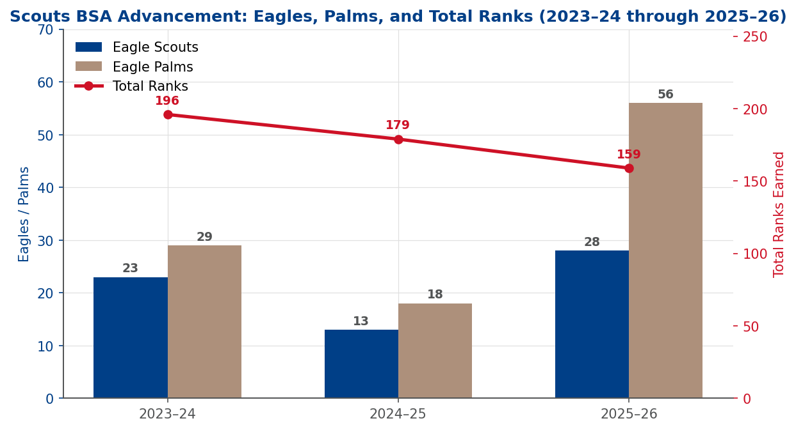
Figure 5.1 — Scouts BSA Advancement: Eagles, Eagle Palms, and Total Ranks (2023–24 through 2025–26)
Program Year | Total Ranks | Eagle Scouts | Merit Badges | Eagle Palms
2023–24 | 196 | 23 | 1,106 | 29
2024–25 | 179 | 13 | 958 | 18
2025–26 | 159 | 28 | 901 | 56
The most striking trend is the surge in Eagle Scout completions from 13 in 2024–25 to a record 28 in 2025–26 — more than double the prior year. The companion increase in Eagle Palms from 18 to 56 confirms this is an exceptionally high-achieving cohort. Over three program years, the district produced 64 Eagle Scouts — a meaningful contribution to the community.

5.2 Eagle Scout Production by Unit
Unit | 2023–24 | 2024–25 | 2025–26 | 3-Yr Total
Troop 1313 (B) | 5 | 2 | 10 | 17
Troop 1103 (B)* | 2 | 1 | 4 | 7
Troop 1005 (B) | — | — | 5 | 5
Troop 9191 (G)* | 2 | 1 | 2 | 5
Troop 1396 (B) | 2 | 2 | 1 | 5
Troop 1280 (B) | 3 | — | 1 | 4
Troop 1369 (B) | 1 | — | 2 | 3
Troop 1365 (B) | 2 | 1 | — | 3
Troop 1378 (B)* | 1 | 2 | — | 3
Troop 1305 (B) | — | 1 | 1 | 2
Other Units | 5 | 3 | 2 | 10
District Total | 23 | 13 | 28 | 64
* Confirmed closed. Eagles credited reflect completions prior to or shortly after unit closure.
Troop 1313 is the district's Eagle powerhouse with 17 Eagles over three years — 27% of all district Eagles. Its 10-Eagle year in 2025–26 is exceptional for any single troop. Troop 1005's burst to 5 Eagles in 2025–26 (after zero in prior years) is consistent with that unit's broader growth story. The confirmed closure of Troops 1103 and 9191 eliminates two units with demonstrated Eagle production capacity.

5.3 Cub Scout Advancement
Cub Scout rank advancement totaled 162 ranks across all levels in 2025 and 97 year-to-date in 2026. Notably, Arrow of Light completions have held relatively steady (21 in 2025, 20 in 2026 YTD) even as Webelos enrollment declined, suggesting a higher percentage of current Webelos are completing the program. Calendar years 2021–2024 are excluded from this analysis: 2021–2023 data was missing or all-zero in OLR (post-pandemic data gap), and 2024 totals did not reconcile with their level-by-level breakdown (a 31-rank discrepancy).
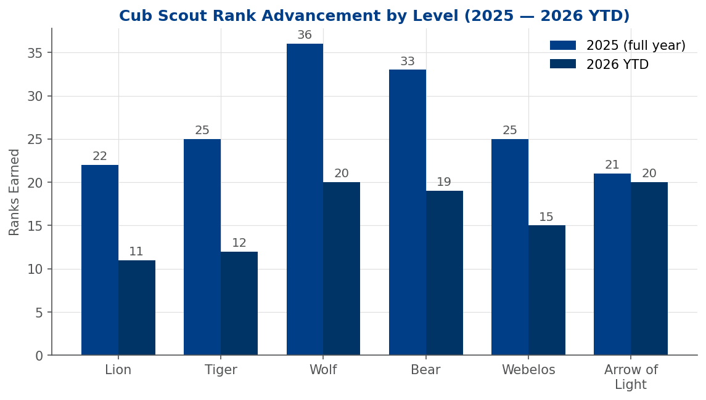
Figure 5.2 — Cub Scout Rank Advancement by Level (2025 — 2026 YTD)
Red Flag
Pack 1315 and Pack 1369 show zero recorded rank advancements in any year, despite each having 13–24 active youth. Either advancement is not being recorded in OLR or den programs are not being run — both require immediate commissioner attention.

5.4 Priorities for Incoming District Chairman
- Investigate zero advancement records in Pack 1315 and Pack 1369 — confirm whether it's a recording gap or program failure.
- Publicly congratulate Troop 1313 leadership and the 10 Eagles of 2025–26 — public recognition reinforces behavior.
- Address Troop 1365 advancement decline (75→17 merit badges year-over-year) with a direct unit service visit.
- Monitor the Eagle pipeline for 2026–27; Scoutmasters should identify First Class and Star Scouts on track for Life and Eagle.
- Establish Arrow of Light completion as a prerequisite emphasis for Webelos crossover; the current higher completion rate on a smaller Webelos pool is worth sustaining.

6. Leader Training Analysis
Trained leaders deliver better programs, retain more youth, and provide safer environments. This analysis covers position-based training and Youth Protection Training (YPT) compliance for Anawanna Trails District 13 as of April 14, 2026.
⚠ URGENT — Mass YPT Expiration: May 31, 2026
118 of 205 rostered adults (57.6%) have Youth Protection Training expiring simultaneously on May 31, 2026 — 46 days from the April 14 report date. Any adult whose YPT expires may not participate in Scouting activities. Personal outreach to every unit Key 3 must begin immediately.

6.1 District Training Status Summary
240  Unit Leaders Rostered | 142  Trained Leaders (59%) | 81  Direct Contact Leaders | 47  DCLs Trained (58%)

Position | DCL? | Total | Trained | Not Trained | % Trained
Scoutmaster | Yes | 13 | 7 | 6 | 54%
Asst. Scoutmaster | Yes | 30 | 17 | 13 | 57%
Cubmaster | Yes | 10 | 6 | 4 | 60%
Asst. Cubmaster | Yes | 2 | 2 | — | 100%
Den Leader | Yes | 21 | 11 | 10 | 52%
Asst. Den Leader | Yes | 5 | 4 | 1 | 80%
Committee Member | No | 110 | 59 | 51 | 54%
Committee Chair | No | 22 | 13 | 9 | 59%
Chartered Org. Rep. | No | 22 | 19 | 3 | 86%
Unit Coll. Scouter | No | 4 | 4 | — | 100%
DCL Total | — | 81 | 47 | 34 | 58%
Overall Total | — | 240 | 142 | 98 | 59%

6.2 Unit-by-Unit Training Rates

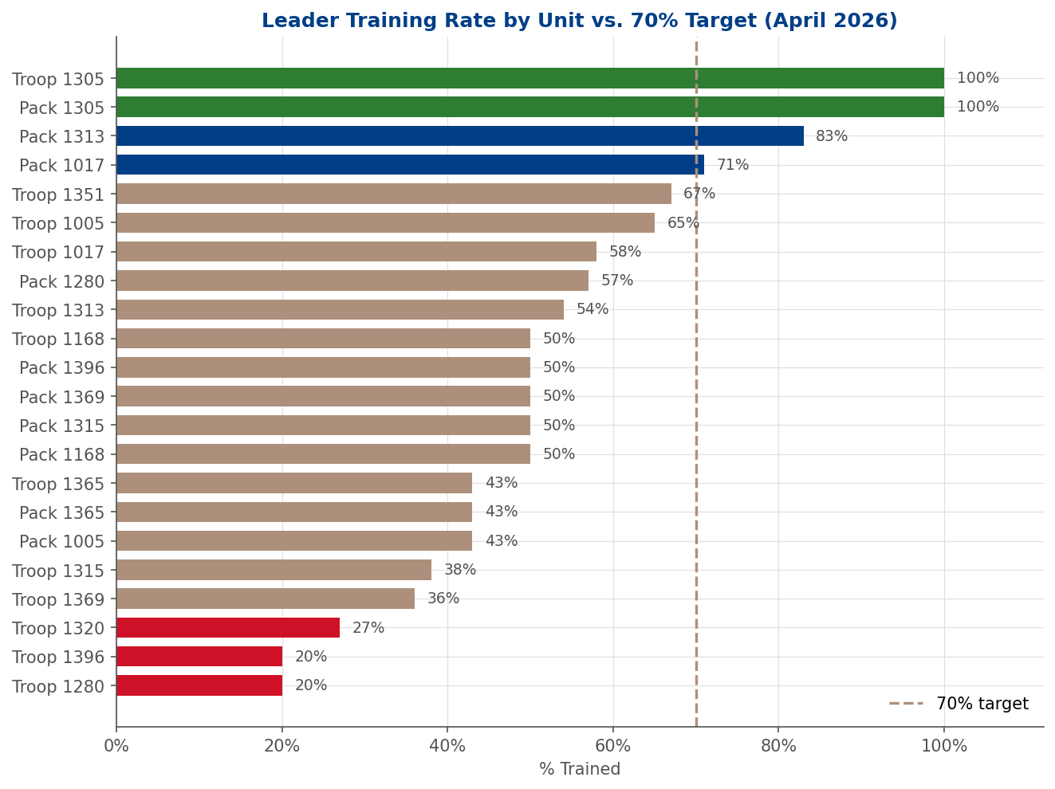
Figure 6.1 — Leader Training Rate by Unit vs. 70% Target (April 2026)
Two units stand out as models of excellence: Pack 1305 and Troop 1305 each achieved 100% trained status across all leaders and DCL positions. Three units require urgent attention: Troop 1280 (20%), Troop 1396 (20%), and Troop 1320 (27%) all have trained rates below 30% and Direct Contact Leader trained rates of 0%. Low training in these units correlates directly with their membership decline and service disengagement. Troop 1351, new to this reporting cycle, opens at 67% overall and 100% DCL — a promising starting baseline.

6.3 YPT Expiration Details

Group / Unit | Leaders Expiring by Jul 14 | Primary Exp. Date | Notes
District (MBC / Staff) | 53 | 05/31/2026 | Includes Merit Badge Counselors
Troop 1313 | 12 | 05/31/2026 | Largest troop
Troop 1017 | 8 | 05/31/2026 | 8 of 19 unit leaders
Pack 1305 | 7 | 05/31/2026 | Protect 100% trained standing
Troop 1369 | 6 | 05/31/2026 | 6 of 14 unit leaders
Pack 1369 / Troop 1320 / Pack 1168 | 4–5 each | 05/31/2026 | Multiple unit leaders
Troop 1005 / Pack 1365 / Troop 1396 | 4 each | 05/31/2026 | Troop 1396 already at 20% trained
District Total | 131 of 205 (63.9%) | 05/31/2026 (primary) | 118 expire simultaneously

6.4 Priorities for Incoming District Chairman

Immediate Actions (Before June 1, 2026)
- Launch a district-wide YPT renewal campaign immediately — direct personal outreach to every unit Key 3, not just a Roundtable reminder.
- Alert Pack 1305 specifically about its 7 expiring leaders to protect its exceptional 100% trained standing.
- Notify Lisa Maust (MBC) — YPT expired April 13, 2026; she must renew before functioning in any Scouting role.

Near-Term (Q2–3 2026)
- Conduct a targeted Scoutmaster training push — 6 of 13 Scoutmasters are untrained, the single most consequential training gap in any unit.
- Prioritize Troop 1313 training outreach — 17 untrained of 37 leaders; moving from 54% to 70% requires only 6 additional trained leaders.
- Address the 1280/1320/1396 cluster — all below 30% trained with DCL rates of 0%. These units need relationship-building, not reminder emails.
- Set a district goal of 70% trained leaders by calendar year-end 2026 — requires approximately 26 additional trained leaders.

7. Service Hours Analysis
Community service is a cornerstone of the Scouting mission. Across six completed program years (2020–2025), district units collectively reported 7,162.6 service hours across 2,449 projects. Reported figures represent only recorded service; actual service performed is almost certainly higher, as many units underutilize the OLR/Internet Advancement reporting system.

7.1 Annual Service Hours Trend
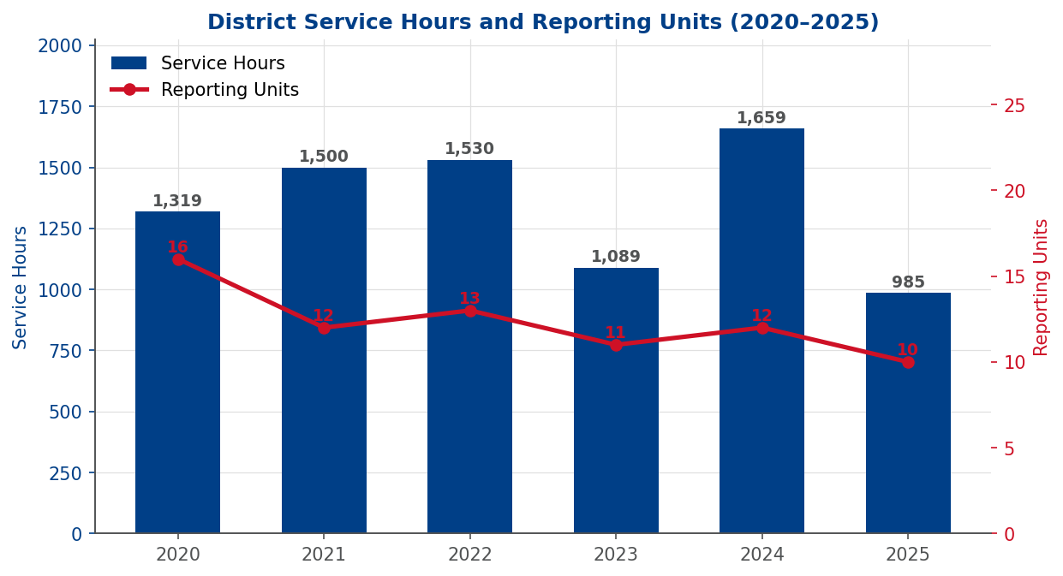
Figure 7.1 — District Service Hours and Reporting Units (2020–2025)
Year | Projects | Unit Service Hours | Reporting Units
2020 | 403 | 1,319.0 | 16
2021 | 527 | 1,500.0 | 12
2022 | 455 | 1,530.3 | 13
2023 | 347 | 1,089.3 | 11
2024 | 405 | 1,659.3 | 12
2025 | 312 | 984.9 | 10
2026 YTD | 11 | 17.0 | 2
Eagle Scout project hours in the source report are council-wide (Laurel Highlands Council 527) and are not district-specific; they are not included as a district service metric.
Service peaked in 2024 at 1,659 hours — the six-year high — before falling sharply to 985 hours in 2025, a 41% decline. The steady contraction in reporting units from 16 (2020) to 10 (2025) mirrors the unit closure trend. Each closed unit removes current service output and all future capacity.

7.2 Key Unit Service Performance
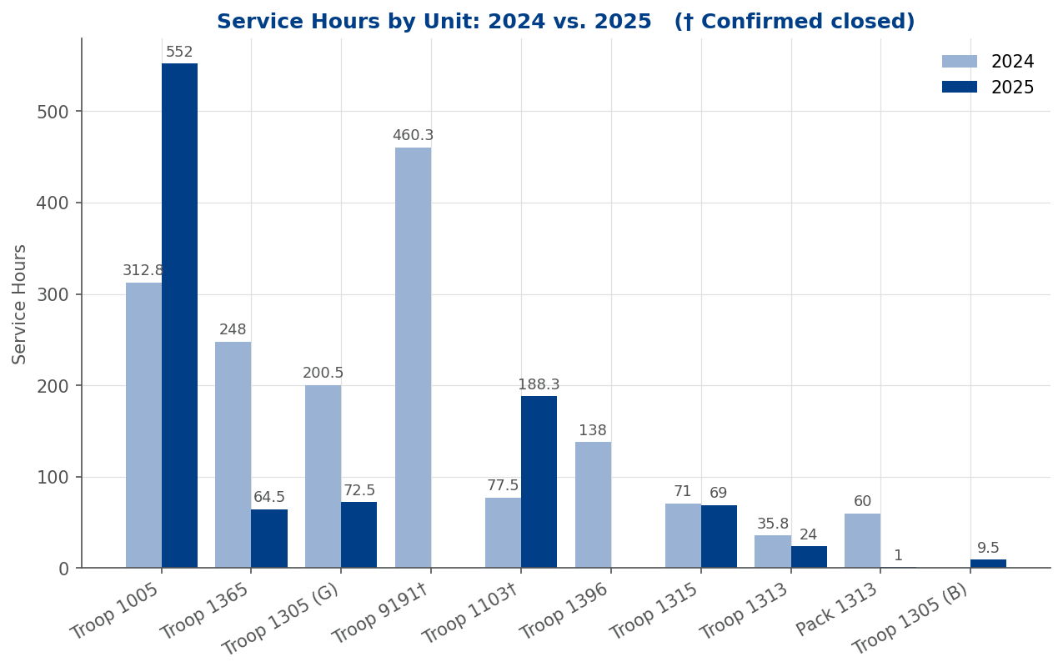
Figure 7.2 — Service Hours by Unit: 2024 vs. 2025
Troop 1005 is the clear standout, more than doubling its already-strong 2024 output (312.75 hours) to reach 552 hours in 2025 — an increase of 239 hours across 130 projects spanning disaster relief, environmental conservation, and community programs. This troop's service culture is genuinely embedded, not treated as an obligation.
At the other end of the spectrum, Troop 1280 reported a near-complete collapse (395.5 hours in 2022 to just 3 in 2025). Troop 1305 (Boys), once the district's second-most prolific service unit (341 hours in 2020), now reports only 9.5 hours. Troop 1313, the district's largest troop, contributes only ~1 service hour per Scout per year — far below its potential.

7.3 Service Categories
Service projects span six primary categories: Other/Community (largest by volume), Environmental/Conservation (consistently strong), Food/Shelter Insecurity (primarily Troops 1305 and 1031), Children/Education (growth in 2023–25 driven by Troop 1005), Landscape/Beautification (Troop 1365 and Pack 1313), and Disabled/Elderly (Troops 1365 and 1396).

7.4 Priorities for Incoming District Chairman
- Recognize Troop 1005 publicly for its extraordinary 552 service hours — a district record. Recognition reinforces culture.
- Contact Troop 1396 to determine whether 2025 service was completed but not entered in Internet Advancement.
- Engage Troop 1280 leadership directly — the collapse from 395.5 to 3 hours requires an immediate response.
- Address the gap between Troop 1313's enrollment (31–43 Scouts) and service output (24 hours in 2025). A per-Scout target of 5–10 hours annually would yield 150–300 hours from this troop alone.
- Rebuild service culture in Troop 1305 (Boys) — was the district's #2 service unit in 2020–21, now nearly absent from the data.
- Establish a district service standard: 100 reported hours per active troop annually as an achievable benchmark.
- Promote Internet Advancement reporting at every Roundtable — the district almost certainly understates its actual community impact.

Appendix — Data Sources
All data in this consolidated report is sourced from Scouting America's Online Registration (OLR) system and Internet Advancement system, filtered to Anawanna Trails District 13, Laurel Highlands Council 527. Report prepared April 2026 for District Chairman transition.
Section | Primary Data Source | Report Date
Membership | OLR Membership by Month — March snapshots 2022–2026 | April 2026
Retention | OLR Retention Rate Report — December 2020 through March 2026 | April 14, 2026
Total Youth Served | OLR TYS by Age and by Grade/Gender — 2024–2026 YTD | April 6, 2026
Geographic Analysis | OLR Membership by Unit and community — 2022–2026 | April 2026
Advancement | OLR Detailed Advancement Reports — Cubs CY2024–2026; BSA PYs 2022–2026 | April 15, 2026
Training | Trained Leaders Status Report + Safeguarding Youth Training Aging Report | April 14, 2026
Service Hours | Internet Advancement Service Hours Report — 2020–2026 YTD | April 15, 2026
Order of the Arrow | Anawanna Trails Lodge chapter ceremony and membership records 2020–2025 | April 2026
Note: 2026 figures marked YTD reflect enrollment or activity as of April 2026 and are not projected full-year totals. YOY comparisons for 2026 are made against the same approximate calendar period in 2025 for like-for-like measurement.
Known data corrections incorporated: Troop 1369 → ZIP 15321 (Cecil Township) and Troop 1396 → ZIP 15021 (Burgettstown) reflect corrected unit-ZIP assignments. Eagle Scout project hours from the source service-hours report are council-wide (LHC 527), not district-specific, and are excluded from district service metrics.

